**A PROJECT REPORT**

**GLOBAL PROPERTY MANAGEMENT**

**AND SERVICE PROVIDER**

**Submitted by**

**GOPI VIRADIYA(120370131003)**

**NILAM DANKHARA(120370121128)**

**SUJA PATEL(120370131140)**

**DIKSHA SHARMA(120370131176)**

**In fulfillment for the award of the degree**

**Of**

**BACHELOR OF ENGINEERING**

**In**

**Computer Science and Engineering**



**Parul Institute of Engineering and Technology, Vadodara**

**Gujarat Technological University, Ahmedabad**

**DECEMBER 2013**

**Parul Institute of Engineering and Technology**

Computer Science and Technology

**CERTIFICATE**

**Date:**

This is to certify that the dissertation entitled “**Global Property Management and Service Provider**” has been carried out by **Gopi Viradiya, Nilam Dankhara, Suja Patel** and **Diksha Sharma** under my guidance in fulfillment of the degree of Bachelor of Engineering in Computer Science and Engineering (7th Semester/8th Semester) of Gujarat Technological University, Ahmedabad -during the academic year 2015-16.

Guide: Internal Guide

**Mr. Rohit Srivastva**

Head of the Department

**Acknowledgment**

It is very difficult to express our feelings and we feel short of words for those who have contributed a lot in our training and provided their invaluable cooperation to us. Many people have helped, provided direction as well as technical information and it is our pleasure to acknowledge our debt to the many people involved directly or indirectly involved in development of this project.

Our deep sense of gratitude is extended to Mr. Rohit Srivastva (Asst.Professor, CSE department) whose continuous encouragement, suggestion, and constructive criticism have been invaluable assets throughout the project work.

We are also thankful to Mr. Harshal Shah (HOD, CSE Department) and Parul Institute of Engineering and Technology for helping us to build our career and laying down a platform, which will help us to build a career in software industry.

We would be unjust not to mention the help forwarded to us by our friends who were ever ready to support us. Finally, we express our sincere gratitude to our parents who have encouraged us to try our best to carry out the project.

**Table of Contents**

|  |  |  |
| --- | --- | --- |
| **Sr. No.** | **Topic Description** | **Page No.** |
|  | **Acknowledgement** | 3 |
|  | **List of Tables** | 7 |
|  | **List of Figures** | 8 |
|  | **Abstract** | 10 |
|  |  |  |
| **1** | **Introduction of Project**   |  |  | | --- | --- | | 1.1 | Project Profile | | 1.2 | Project Definition | | 1.3 | Scope of Project | | 1.4 | Modular Description | | 1.5 | Objectives | |  |  | | |  | | --- | | 11 | | 12 | | 12 | | 13 | | 14 | |  | |
| **2** | **Brief History Of Work**   |  |  | | --- | --- | | 2.1 | Introduction To ASP.NET  2.1.1 Features | | 2.2 | Detailed Description of the topic  2.2.1 Architecture  2.2.2 Application life cycle | | 2.3 | Security | | 2.4 | Advantages  Disadvantages | | |  | | --- | | 15  15 | | 19  22 | | 23 | | 23  24 | |
| **3** | **Project Analysis**   |  |  | | --- | --- | | 3.1 | UML Diagram | | 3.2 | Activity Diagram | | 3.3 | Sequence Diagram | | 3.4 | Class Diagram | | 3.5  3.6  3.7 | E-R Diagram  Data Dictionary  3.6.1 Database Tables  Implementation Screen Short | |  |  | | |  | | --- | | 26 | | 30 | | 36 | | 46 | | 47 | | 48  48  54 | |
| **4**  **5** | **Requirement Analysis**   |  |  | | --- | --- | | 4.1 | User Characteristics | | 4.2 | Hardware Requirements | | 4.3 | Requirements for Development | | 5.1  5.2 | 4.3.1 Functional Requirements  4.3.2Non-Functional  Requirements    **Coding, Testing & Implementation**  Coding Standards  Software Testing  5.2.1 Overview of Test Model  5.2.2 Modules of Testing  5.2.3 Testing strategy  5.3.4 Test Cases  **Conclusion**  **References** | |  |  | | |  | | --- | | 69 | | 69 | |  | | 70 | | 70  71  76  76  79  83  86  87  88 | |
|  |  |  |
|  |  |  |
|  |  |  |

**List of Tables**

|  |  |  |
| --- | --- | --- |
| **Table No.** | **Table Description** | **Page No.** |
| Table 3.5.1 | Login | 48 |
| Table 3.5.2 | Customer | 48 |
| Table 3.5.3 | Builder & Real-Estate | 49 |
| Table 3.5.4  Table 3.5.5  Table 3.5.6  Table 3.5.7  Table 3.5.8 | Filter  Service Provider  Service  Property  New Project | 49  50  51  52  53 |
|  |  |  |

**List of Figures**

|  |  |  |
| --- | --- | --- |
| **Figure No** | **Figure Description** | **Page No.** |
| Figure 2.2.1 | Architecture of the ASP.NET | 20 |
| Figure 3.1.1 | Use Case Diagram for Admin | 26 |
| Figure 3.1.2 | Use case diagram for Customer | 27 |
| Figure 3.1.3 | Use Case Diagram for Builder & Real-Estate | 28 |
| Figure 3.1.4 | Use Case Diagram for Service Provider | 29 |
| Figure 3.2.1 | General Activity Diagram for system | 30 |
| Figure 3.2.2 | Activity Diagram for Visitor | 31 |
| Figure 3.2.3 | Activity Diagram for Admin | 32 |
| Figure 3.2.4 | Activity Diagram for Customer | 33 |
| Figure 3.2.5 | Activity Diagram for Builder | 34 |
| Figure 3.2.6 | Activity Diagram for Real-Estate | 34 |
| Figure 3.2.7 | Activity Diagram for Service Provider | 35 |
| Figure 3.3.1 | Sequence Diagram for Login | 36 |
| Figure 3.3.2  Figure 3.3.3  Figure 3.3.4  Figure 3.3.5  Figure 3.3.6  Figure 3.3.7  Figure 3.3.8  Figure 3.3.9  Figure 3.3.10  Figure 3.4  Figure 3.5  Figure 3.7.1  Figure 3.7.2  Figure 3.7.3  Figure 3.7.4  Figure 3.7.5  Figure 3.7.6  Figure 3.7.7  Figure 3.7.8  Figure 3.7.9  Figure 3.7.10  Figure 3.7.11  Figure 3.7.12  Figure 3.7.13  Figure 5.2.2  Figure 5.2.3  Figure 5.2.4 | Sequence Diagram for Forget Password  Sequence Diagram for Change Password  Sequence Diagram for Property handling by Admin  Sequence Diagram for Service handling by Admin  Sequence Diagram for Property Search  Sequence Diagram for Service Search  Sequence Diagram for Registration  Sequence Diagram for Update Profile  Sequence Diagram for Feedback  Class Diagram for System  E-R Diagram for System  Home Page  Login Page  Registration Page  Forgot Password  Customer Home Page  Post Property  Show Property  My Gallery  Show Services  Contact Us  Bootstrap view of Feedback  Admin Login Page  Admin Page  Modules of Testing  Testing Strategy  Test Cases | 37  38  39  40  41  42  43  44  45  46  47  54  61  61  62  62  64  66  66  67  68  69  70  70  63  80  84 |

**Abstract**

Global property management and service provider is a system which is used for providing new or old properties like 2bhk,3bhk,flats,duplexes,tenaments and plots etc. To the customers according to the budget, area as well as the facilities and amenities provided to the customer. The user can buy, sell or rent the properties using our system. The customer can register at our website using username and password and then he/she will be able to see the details of the builder and services provided. At our website the owner of the property can upload his/her properties pictures or videos, so that the buyer can get the whole view of the property. The admin will directly handle the profiles of the service provides. Using our system the user and owner can communicate easily. The builders can register using user ID’s and password and can upload all the details of their property. The real estate can also get the services by our system and can find details about builders the admin will allow the registration of new customer and builders. Admin can remove old services from the system. The admin gives approval for the addition of new projects. The admin can offer gift vouchers to the customers. The services provided by the admin could be like plumber, electrician, carpenter etc. The builder uploads the pictures or videos as well for customer satisfaction. The facilities and amenities include wifeservices, swimming pool, security, club house, library etc. there are some people who only visit the website and does not register because of any reason they are known as visitor.

**Chapter:1**

**Introduction to Project**

## 1.1 Project Profile:

**Project Name :**  Global Property Management and Service Provider

**Project Type :**  IDP(Industry Define Project)

**Development Team :** Gopi Viradiya

Nilam Dankhara

Suja Patel

Diksha Sharma

**Company Name :** The One Web Technology

**External Guide :** Mr. Kuldeep N. Virpura Solanki(Developer)

**Internal Guide :** Mr. Rohit Srivastva (Asst. Professor) CSE Dept.

**Tools &Technology :**

**Server Side Technology:**

ASP.net with C#

**Client Side Technology:**

HTML5

CSS3

**Back-End tools :** My Sql Server2008R2

Bootstrap

JavaScript

C#

## 1.2 Project Definition:

Global property management and service provider is a system which is used for providing new or old properties like 2bhk,3bhk,flats,duplexes,tenaments and plots etc. To the customers according to the budget, area as well as the facilities and amenities provided to the customer. The user can buy, sell or rent the properties using our system. In our system user can also search the services .

## 1.3 Scope of Project:

**Easy to find for Property:** There will be new or old property easily available by which customer can easily search the property for buy and sell purpose. Plus we are providing the facility to the customer if they want sell their property on our website. Also there will be option for the rent purpose, if any customer want to give their own property on rent purpose they can give over there easily. This system save the time of people who need some fresh and new properties in same or different city/state

**Easy to find for Services:** There will be any services like plumber, electrician, carpenter etc can be easily provided. Service provider can upload video and photos of their services, so it's became very for the customers for requesting of any kind of services which they need. This system save the time of people who need excellent services in same or different city/state.

## 1.4 Modular Description:

I. Visitor :

o Only view the External view of the website.

o Cannot get the detail of the builders and any other personal information.

o Can see the pictures and videos of the properties.

II. Customer :

o Can register themselves and get their ID and password.

o Only after registration they can see the details of the builders.

o Can see the contact details and information of the service provider.

III. Builder :

o Can also register themselves using user ID’s and password.

o Can add new, old or any type of property which they want to sell or give on rent.

o Can upload pictures and videos of their property to give a proper view of the property to the customer.

IV. Real-Estate :

o Can buy or sell or give on rent a bulk of properties.

o Also have their registration ID’s and passwords.

V. Service provider :

o Directly handled by the admin.

o Customer can get all the details of any kind of service provider.

VI. Admin:

o Admin will handle builder’s registration.

o Accept the request sent by the user for the registration purpose.

o Can add the new services in a system.

o Add new project by giving approval.

o See the Reports and Feedbacks.

o Extend the time duration for providing service.

o Offer gift voucher to the customer.

##### 1.5 Objectives:

The main objective of our website is to save the time and money of the user. Also the objective of this website is to give comfort and easy to use by the user. The user has to feel very realistic.

**Chapter 2:**

**Brief history of work**

##### Introduction to the ASP.net

ASP.NET is the latest version of Microsoft's Active Server Pages technology (ASP). ASP.NET is a part of the Microsoft .NET framework, and a powerful tool for creating dynamic and interactive web pages.

The .NET Framework is a library used to create both computer-based and web-based applications. It is made of different parts. The section that deals with computer applications is referred to as Windows Forms. The part dedicated to the web is called ASP.NET.  
 **Active Server Pages (ASP)** is a technology developed primarily by Microsoft to create dynamic web sites that allow a visitor to submit values to a web page. The web page would then transmit the results to a web server. This technology requires some use and knowledge of a scripting language such as VBScript or JavaScript. It is also easily understandable to Visual Basic programmers because both use the same approach to solve problems. To enhance it, Microsoft developed ASP.NET. This new approach allows you to use the .NET Framework and its rich features to create web-based applications.

**2.1.1 Features**

ASP.NET is the extended part of asp. Since both is used to create dynamic web pages. ASP.NET is not just a simple upgrade or the latest version of ASP. ASP.NET redesigns the whole process. It's still easy to grasp for new comers but it provides many new ways of managing projects. Below are the features **of ASP.NET**,

**Easy Programming Model:**

ASP.NET has made an easy way to make dynamic web pages. ASP.NET makes building real world Web applications dramatically easier. Displaying data, validating user input, and uploading files are all amazingly easy. Best of all, ASP.NET pages work in all browsers including Netscape, Opera, AOL, and Internet Explorer.

**Flexible Language Options:**

ASP.NET has major advantage of choosing many languages, in other words there can be used near about 25 languages in one platform and in other way classic ASP, which supports only interpreted VBScript and Jscript**,** giving you unprecedented flexibility in your choice of language.

**Great Tool Support:**

You can harness the full power of ASP.NET using any text editor, even Notepad. But VisualStudio .NET adds the productivity of Visual Basic-style development to the Web. Now we can visually designASP.NET Web Forms using familiar drag-drop-double-click techniques, and enjoy full-fledged code support including statement completion and color-coding.VS.NETalso provides integrated support for debugging and deploying ASP.NET Web applications.

**Rich Class Framework:**

In ASP.NET, everything is object and class is collection of objects. Thus it can be said ASP.NET is rich in class. Application features that used to be hard to implement, or required a 3rd-party component, can now be added in just a few lines of code using the .NETFramework. The .NET Framework offers over 4500 classes that encapsulate rich functionality like XML, data access, file upload, regular expressions, image generation, performance monitoring and logging, transactions, message queuing, SMTP mail, and much more.

**Compiled execution:**

ASP.NET is much faster than classic ASP, while preserving the "just hit save" update model of ASP. However, no explicit compile step is required.ASP.NETwill automatically detect any changes, dynamically compile the files if needed, and store the compiled results to reuse for subsequent requests. Dynamic compilation ensures that your application is always up to date, and compiled execution makes it fast. Most applications migrated from classic .Meaning of this if ASP.NET program is compiled once, if we make change in program then only changed program will be compiled not whole, thusASP.NET has made the processing fast in comparison to asp.

**Rich output caching:**

ASP.NET is rich in caching in comparison toasp. ASP.NET output caching can dramatically improve the performance and scalability of our application. When output caching is enabled on a page, ASP.NETexecutes the page just once, and saves the result in memory in addition to sending it to the user. When another user requests the same page, ASP.NETserves the cached result from memory without re-executing the page. Output caching is configurable, and can be used to cache individual regions or an entire page.

**Code Reusability:**

Code reusability is the art of using existing code to achieve better productivity and ease of maintenance. Code reusability increases the readability of our code and decreases the execution time.

**Web-Farm Session State:**

ASP.NET session state lets you share session data user-specific state values across all machines in your Web farm. Now we can hit different servers in the Web farm over multiple requests and still have full access to her session. And since business components created with the .NET Frameworkare free-threaded, we no longer need to worry about thread affinity.

**Enhanced Reliability:**

ASP.NETensures that your application is always available to your users. Meaning of this ASP.NETis more reliable than asp. It is more user friendly than asp.

**Memory Leak, Deadlock and Crash Protection:**

ASP.NET automatically detects and recovers from errors like deadlocks and memory leaks to ensure your application is always available to your users. For example, say that your application has a small memory leak, and that after a week the leak has tied up a significant percentage of your server's virtual memory. ASP.NETwill detect this condition, automatically start up another copy of the ASP.NET worker process, and direct all new requests to the new process. Once the old process has finished processing its pending requests, it is gracefully disposed and the leaked memory is released. Automatically, without administrator intervention or any interruption of service, ASP.NET has recovered from the error.

**Easy Deployment:**

ASP.NET takes the pain out of deploying server applications. "No touch" application deployment. ASP.NET dramatically simplifies installation of your application. With ASP.NET**,** you can deploy an entire application as easily as anHTML page; just copy it to the server. No need to run regsvr32 to register any components, and configuration settings are stored in an XML file within the application.

**Dynamic update of running application:**

ASP.NETnow lets you update compiled components without restarting the web server. In the past with classic COM components, the developer would have to restart the web server each time he deployed an update. With ASP.NET, you simply copy the component over the existing DLL,ASP.NET will automatically detect the change and start using the new code.

**Easy Migration Path:**

You don't have to migrate your existing applications to start using ASP.NET. ASP.NET runs on IIS side-by-side with classic ASP on Windows 2000 and Windows XP platforms. Your existing ASP applications continue to be processed by ASP.DLL, while new ASP.NET pages are processed by the new ASP.NET engine. You can migrate application by application, or single pages. And ASP.NETeven lets you continue to use your existing classic COM business components.

**XML Web Services:**

XML Web services allow applications to communicate and share data over the Internet, regardless of operating system or programming language. ASP.NET makes exposing and calling XML Web Services simple. Any class can be converted into an XML Web Service with just a few lines of code, and can be called by any SOAP client. Likewise, ASP.NET makes it incredibly easy to call XML Web Services from your application. No knowledge of networking, XML, or SOAP is required.

**Mobile Web Device Support:**

ASP.NET Mobile Controls let you easily target cell phones, PDA’s and over 80 mobile Web devices. You write your application just once, and the mobile controls automatically generate WAP/WML, HTML, or iMode as required by the requesting device.

**Security:**

In ASP.NET2.0, new features provide integrated support for authenticating and authorizing users.ASP.NET membership manages authentication, providing facilities for validating user credentials and helping users to manage their passwords. You can call programmatically to create new users, validate credentials, and get user information using the provided membership service APIs. To make simpler authentication even more, you can use the new login controls, which work with the ASP.NET membership to perform a variety of tasks, often with no extra code required.

* 1. **Detailed Description of the topic**

**2.2.1 Architecture**

ASP.NET has extended into multiple code frameworks, including Web Forms, MVC, Web Page, Web API and SignalR. Initially, all these grew up separately but now they are coming together. Now, you can develop your web site or web application by using Web Forms or MVC or Web Page and services by using Web API or SignalR.

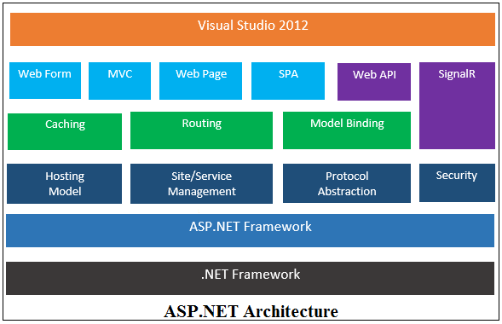

**Components of Asp.NET Architecture:**

**.NET Framework:**

.Net framework is an integrated component of windows operating system that supports development and execution of next generation applications, Windows store apps and services.

**ASP.NET Framework:**

ASP.Net Framework is used to create dynamic website, web application and web services. It is built on the top of .NET Framework.Asp.NET Framework provides you various capabilities like Hosting Model, Site/Service Management, Protocol Abstraction, Security, Caching capability, Routing and Model Binding etc.

**Mainly, Asp.Net can be divides into two parts - Asp.Net Sites and Asp.Net Services.**

**Asp.NET Services:** There are two ways to make Asp.Net Services as given below :

* **Web API:**Asp.Net Web API is a framework for building HTTP services that can be consume by a broad range of clients including browsers, mobiles, iphone and tablets.
* **SignalR: A**SP.NET SignalR is a library that simplifies the process of adding real-time web functionality to applications. Real-time web functionality is the ability to have server code push content to connected clients instantly as it becomes available, rather than having the server wait for a client to request new data.
* **Visual Studio 2012:**The Visual Studio IDE offers a set of tools that help you to write and modify the code for your programs, and also detect and correct errors in your programs. Using Visual Studio 2012 you can build Windows Store apps, desktop apps, mobile apps, ASP.NET web apps, and web services.

**Asp.NET Site:** There are following flavours of Asp.NET Site :

* **Web Forms:** This is the traditional event driven development model. It has drag and drop server controls, server events and state management techniques. This best for rapid application development (RAD) with powerful data access.
* **MVC:** This is a lightweight and MVC (Model, View, Controller) pattern based development model. It provides full control over mark-up and support many features that allow fast & agile development. This best for developing lightweight, interactive and device oriented (i.e. compatible to smart phones, iPhone, tablet, laptop etc.) web application with latest web standards.
* **Web Pages:** This is also a lightweight and Razor syntax based development model. It has built-in template and helpers also provide full control over mark-up. It is best for developing beautiful web application with latest web standards. You can also use Web Matrix which is a free tool and has built-in template; for developing Asp.Net Web Page.
* **SPA:** SPA stands for Single Page Application which helps you to build web applications that include significant client-side interactions using HTML5, CSS3 and JavaScript. It is best to make highly interactive single page dashboard web applications.

**2.2.2 Application life cycle**

The application life cycle has the following stages:

User makes a request for accessing application resource, a page. Browser sends this request to the web server.

A unified pipeline receives the first request and the following events take place:

* + An object of the class Application Manager is created.
  + An object of the class Hosting Environment is created to provide information regarding the resources.
  + Top level items in the application are compiled.

Response objects are created. The application objects such as HttpContext, HttpRequest and Http Response are created and initialized.

An instance of the Http Application object is created and assigned to the request.

The request is processed by the Http Application class. Different events are raised by this class for processing the request

**2.3 Security**

Implementing security in a site has the following aspects:

**Authentication** : It is the process of ensuring the user's identity and authenticity. ASP.NET allows four types of authentications:

* + Windows Authentication
  + Forms Authentication
  + Passport Authentication
  + Custom Authentication

Authorization: It is the process of defining and allotting specific roles to specific users.

**Confidentiality:** It involves encrypting the channel between the client browser and the web server.

**Integrity:** It involves maintaining the integrity of data. For example, implementing digital signature.

**2.4 Advantages & Disadvantages**

**Advantages:**

**Rich controls:** The framework comes with a large set of very robust and useful server and client side controls for creating interactive grids, calendars, wizards, and much more. Many of these have a lot of functionality right out of the box. There is also support for defining your own controls.

**Rapid development:** You can generally throw a fairly dynamic website together pretty quickly with ASP.NET.

**Automatic state fullness:** The view state structure will automatically save the state of controls and other fields for you so you don't have to manage that behind the scenes. This is a big time saver but can have performance

**Built in security:** There is out of the box support for authentication, authorization, and various options for implementation with NTLM, Kerberos, and other standards.

**Disadvantages:**

**Does not allow for easy unit test:** The framework tends not to support automatic unit testing with tools like NUnit very well which makes test-driven development difficult. MVC based framework like Struts or ASP.NET MVC do a better job of this.

**View state:** Often times view state can get really large or have negative effects on performance. This is especially true for some of the more complex server controls.

**Abstracts the wariness away from web programming:** Some people feel that ASP.NET does not fit the general architecture of internet and web based applications. They feel like Microsoft tried to follow the Windows Forms desktop paradigm too closely and it makes for developers that don't have a good grasp on how web apps are different than desktop apps.

**Chapter 3:**

**Project Analysis**

In our system visitors can visit our website as well as register as customer in our place, we have facility for online buying/selling or taking on rent any properties, where customer can book using user id and password. Using our website the customer can buy/sell new/old properties. After booking of the property the customer can see the details of the builder and can contact to the builder and get some extra knowledge about the facilities or property.

User can find the property by location, budget, type, area and mainly city vise. The main feature of our project is, If any customer want some services related to their house then, they just have to register and ask for the service as per they need. All the required services will be provided.

##### 3.1 UML Diagram:

##### 3.1.1 UML for admin:

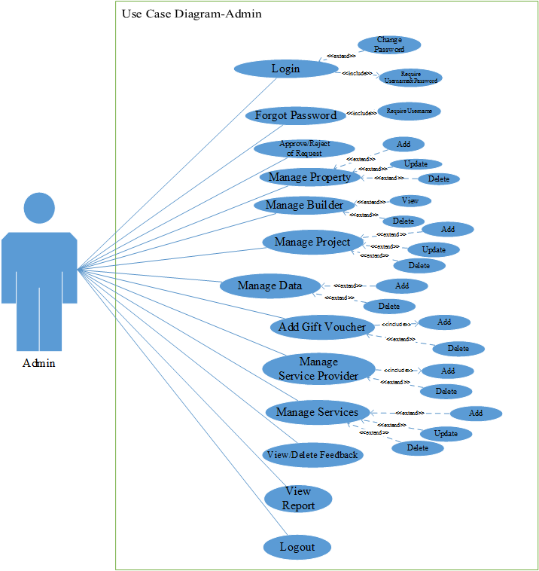

**Figure 3.1.1 Use Case Diagram for Admin**

**3.1.2 UML for Customer:**



**Figure 3.1.2 Use Case Diagram for Customer**

**3.1.3 UML for Real-Estate and Builder :**



**Figure 3.1.3 Use Case Diagram for Real-Estate and Builder**

**3.1.4 UML for Service Provider:**



**Figure 3.1.4 Use Case Diagram for Service Provider**

**3.2 Activity Diagram:**

**General Activity Diagram for System:**

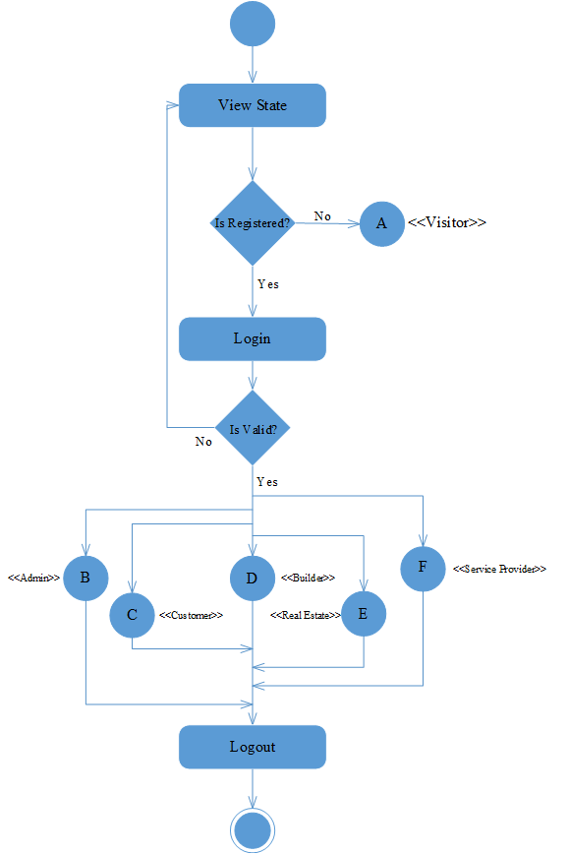

**Figure 3.2 General Activity Diagram for System**

**3.2.1 Activity Diagram for A(Visitor):**



**Figure 3.2.1 Activity Diagram for Visitor**

**3.2.2 Activity Diagram for B(Admin):**

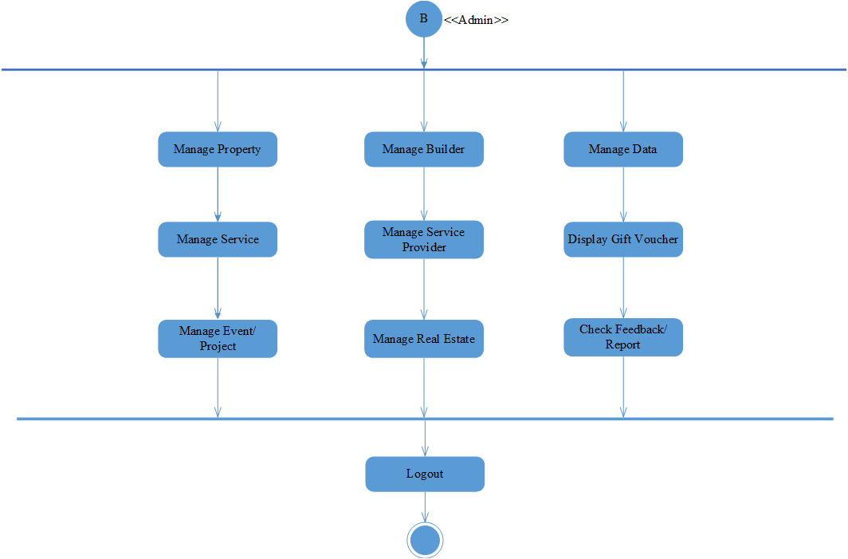

**Figure 3.2.2 Activity Diagram for Admin**

**3.2.3 Activity Diagram For C(Customer):** 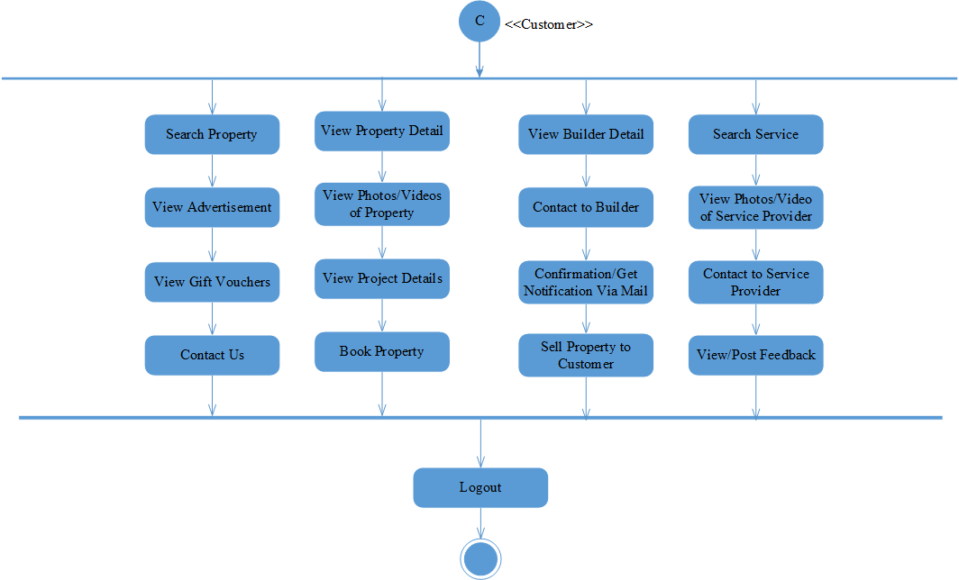

**Figure 3.2.3 Activity Diagram for Customer**

**3.2.4 Activity Diagram For D(Builder): 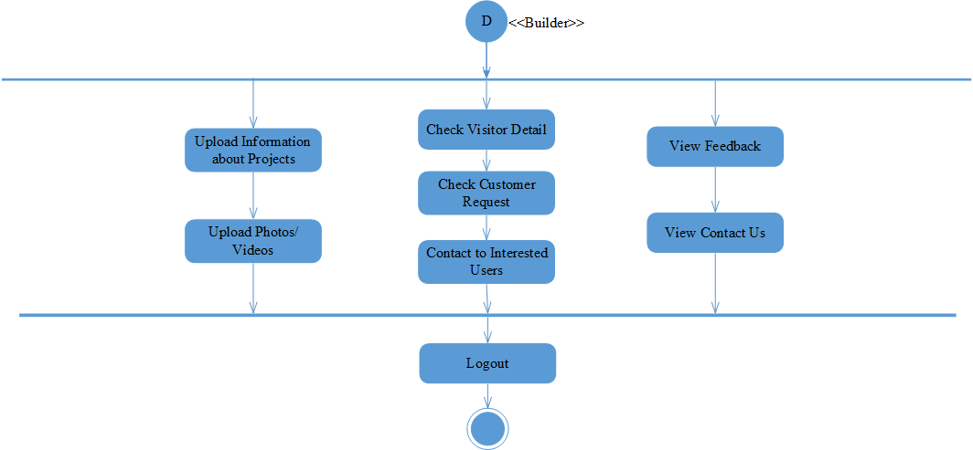 Figure 3.2.4 Activity Diagram for Builder**

**3.2.5 Activity Diagram For E(Real-Estate): 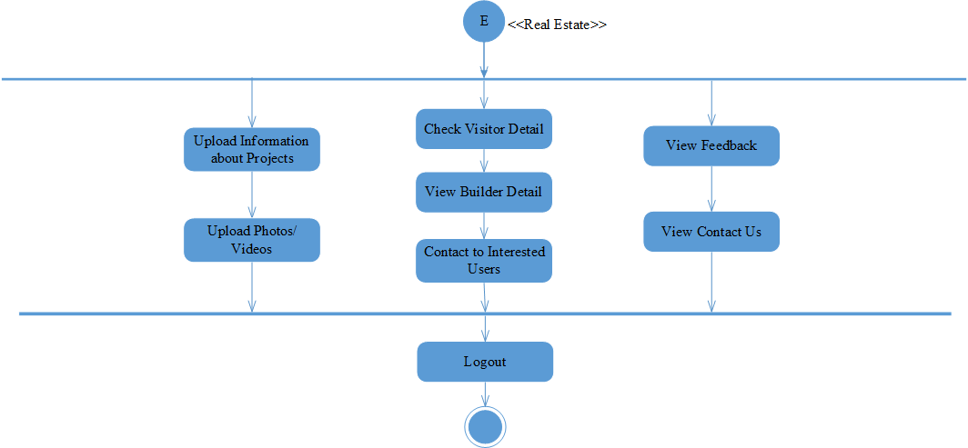 Figure 3.2.5 Activity Diagram for Real-Estate**

**3.2.6 Activity Diagram For F(Service Provider):**

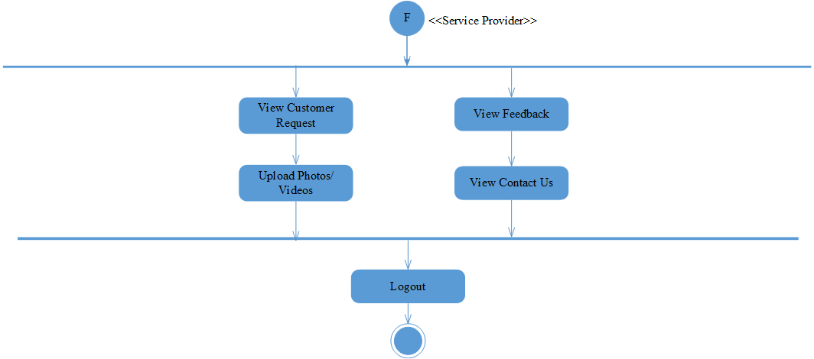

**Figure 3.2.6 Activity Diagram for Service Provider**

**3.3 Sequence Diagram:**

**3.3.1 Sequence Diagram for Login:**

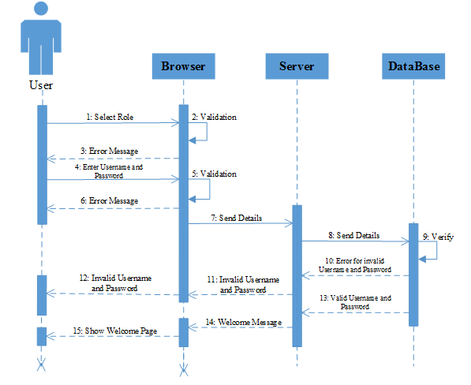

**Figure 3.3.1 Sequence Diagram for Login**

**3.3.2 Sequence Diagram for Forget Password:**

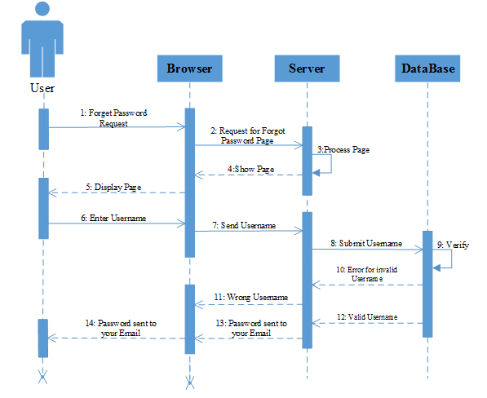

**Figure 3.3.2 Sequence Diagram for Forget Password**

**3.3.3 Sequence Diagram for Change Password:**

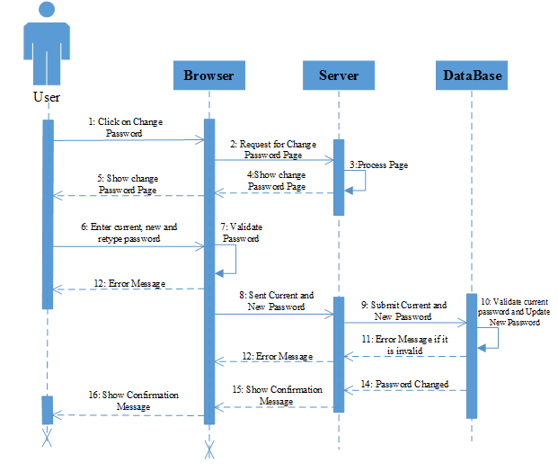

**Figure 3.3.3 Sequence Diagram for Change Password**

**3.3.4 Sequence Diagram for Property handling by Admin:**

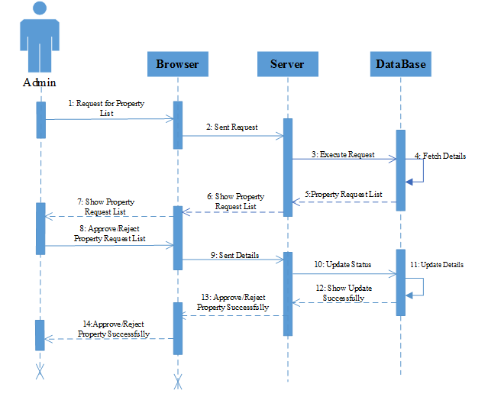

**Figure 3.3.4 Sequence Diagram for Property handling by Admin**

**3.3.5 Sequence Diagram for Service Handling by Admin:**

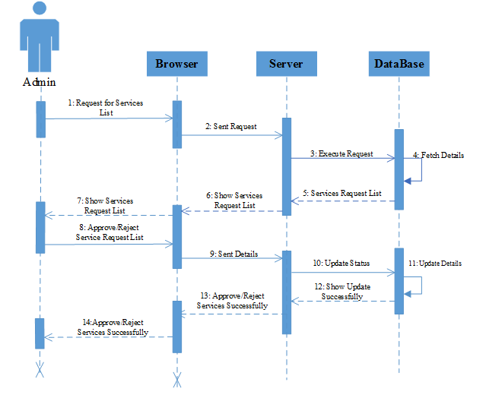

**Figure 3.3.5 Sequence Diagram for Service Handling by Admin**

**3.3.6 Sequence Diagram for Property Search:**

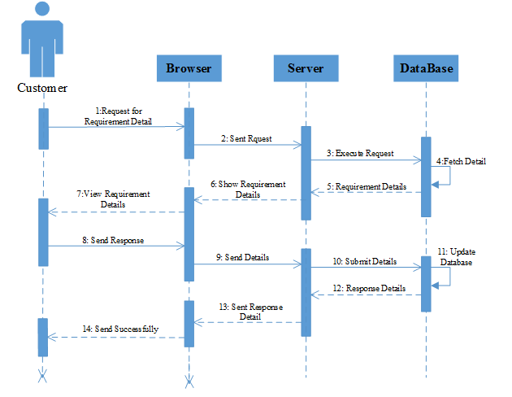

**Figure 3.3.6 Sequence Diagram for Property Search**

**3.3.7 Sequence Diagram for** **Service Search:**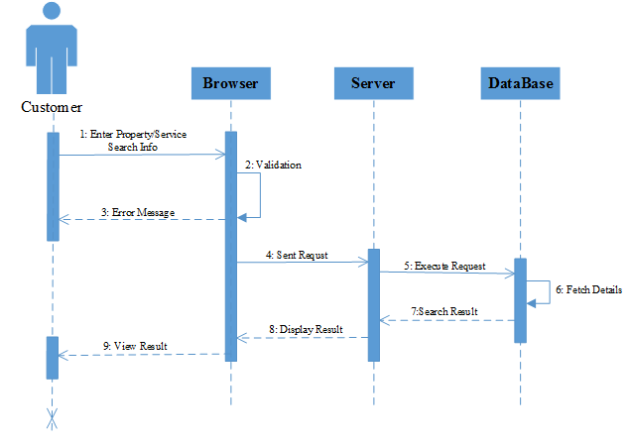

**Figure 3.3.7 Sequence Diagram for Service Search**

**3.3.8 Sequence Diagram for Registration:**

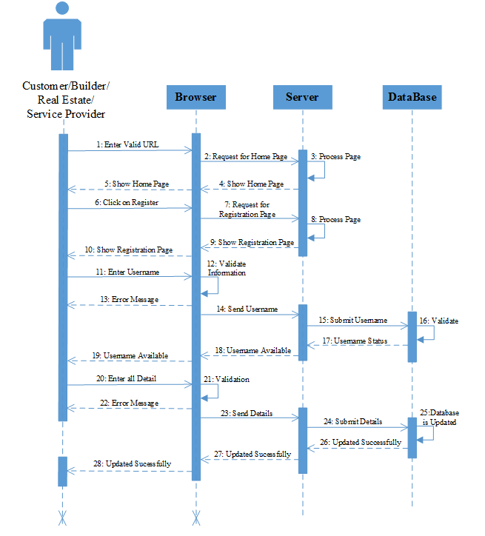

**Figure 3.3.8 Sequence Diagram for Registration**

**3.3.9 Sequence Diagram for Update Profile:**

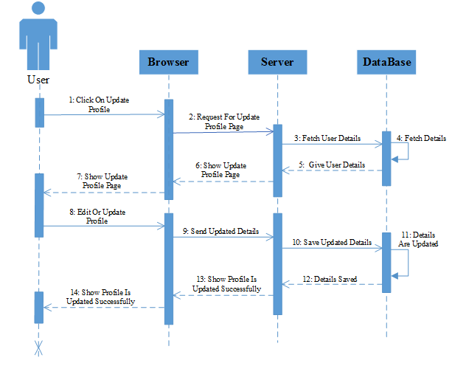

**Figure 3.3.9 Sequence Diagram for Update Profile**

**3.3.10 Sequence Diagram for Feedback:**

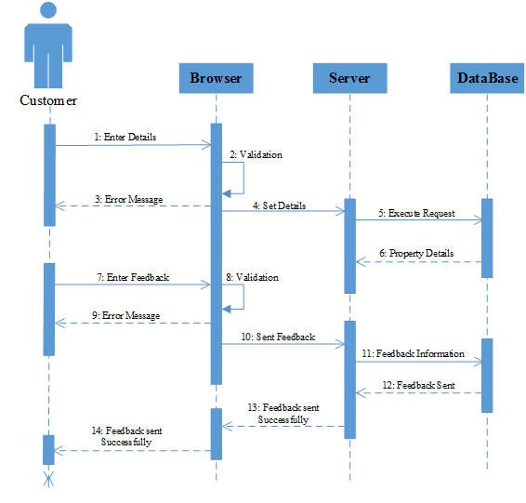

**Figure 3.3.10 Sequence Diagram for Feedback**

**3.4 Class Diagram:**



**Figure 3.4 Class Diagram for System**

**3.5 E-R Diagram:**

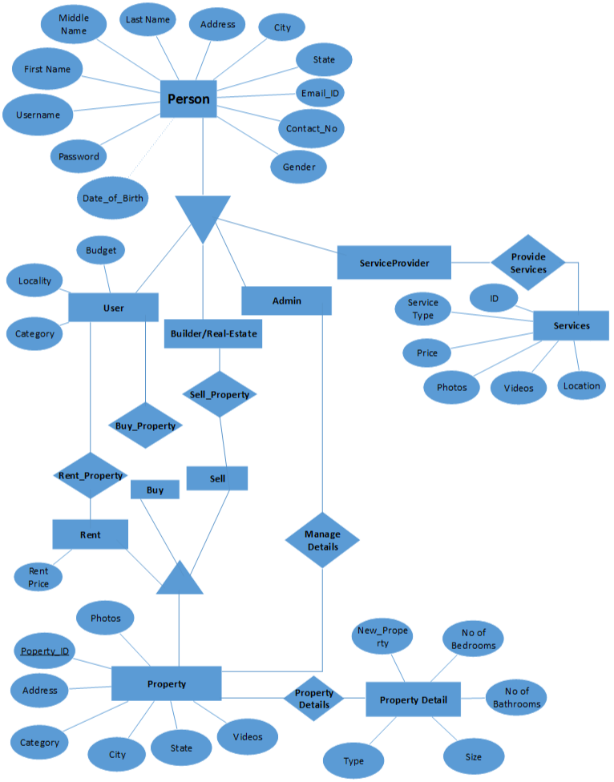

**Figure 3.5 E-R Diagram for System**

**3.5 Data Dictionary**

**Database Tables:**

|  |  |
| --- | --- |
| **Login Master** | |
| **Field** | **Type** |
| Login Id | INT |
| Email Id | VARCHAR (50) |
| Password | VARCHAR (50) |
| Role | VARCHAR (50) |
| OTP | VARCHAR (50) |

**Table 3.5.1 Database Table For Login**

|  |  |
| --- | --- |
| **Customer Master** | |
| **Field** | **Type** |
| Id | INT |
| Login Id | INT |
| Name | VARCHAR (50) |
| Contact No | VARCHAR (50) |
| City | VARCHAR (50) |
| Gender | VARCHAR (50) |
| Image | VARCHAR (50) |

**Table 3.5.2 Database Table For Customer**

|  |  |
| --- | --- |
| **Builder & Real-Estate Master** | |
| **Field** | **Type** |
| Id | INT |
| Login Id | INT |
| Name | VARCHAR (50) |
| Contact No | VARCHAR (50) |
| Company Name | VARCHAR (50) |
| Company Address | VARCHAR (50) |
| City | VARCHAR (50) |
| Gender | VARCHAR (50) |
| Image | VARCHAR (50) |

**Table 3.5.3 Database Table For Builder & Real-Estate**

|  |  |
| --- | --- |
| **Filter Master** | |
| **Field** | **Type** |
| Id | INT |
| Property Type | VARCHAR (50) |
| Location | VARCHAR (50) |
| Area | VARCHAR (50) |
| Price | VARCHAR (50) |

**Table 3.5.4 Database Table For Filter**

|  |  |
| --- | --- |
| **Service Provider Master** | |
| **Field** | **Type** |
| Id | INT |
| Login Id | VARCHAR (50) |
| Name | VARCHAR (50) |
| Service Type | VARCHAR (50) |
| Contact No | VARCHAR (50) |
| City | VARCHAR (50) |
| Gender | VARCHAR (50) |
| Image | VARCHAR (50) |

**Table 3.5.5 Database Table For Service Provider**

|  |  |
| --- | --- |
| **Service Master** | |
| **Field** | **Type** |
| Id | INT |
| Company Name | VARCHAR (50) |
| Address | VARCHAR (50) |
| Contact Person | VARCHAR (50) |
| Contact No | VARCHAR (50) |
| Email Id | VARCHAR (50) |
| Image | VARCHAR (50) |
| Logo | VARCHAR (50) |

**Table 3.5.6 Database Table For Service**

|  |  |
| --- | --- |
| **Property Master** | |
| **Field** | **Type** |
| Id | INT |
| Login Id | VARCHAR (50) |
| Property For | VARCHAR (50) |
| Property Type | VARCHAR (50) |
| Society Name | VARCHAR (50) |
| City | VARCHAR (50) |
| Locality | VARCHAR (50) |
| Address | VARCHAR (50) |
| Description | VARCHAR (100) |
| Total Floor | VARCHAR (50) |
| Bedrooms | VARCHAR (50) |
| Bathrooms | VARCHAR (50) |
| Balconies | VARCHAR (50) |
| Nearby | VARCHAR (200) |
| Furnish status | VARCHAR (50) |
| Wi-Fi Availability | VARCHAR (50) |
| Image | VARCHAR (50) |
| Price | VARCHAR (50) |

**Table 3.5.7 Database Table For Property**

|  |  |
| --- | --- |
| **New Project Master** | |
| **Field** | **Type** |
| Id | INT |
| Site Name | VARCHAR (50) |
| Nearby Location | VARCHAR (50) |
| Type | VARCHAR (50) |
| Builder Name | VARCHAR (50) |
| Area | VARCHAR (50) |
| Built up area | VARCHAR (50) |
| BHK | VARCHAR (50) |
| Bath | VARCHAR (100) |
| Possessions | VARCHAR (50) |
| Update on | VARCHAR (50) |
| Price | VARCHAR (50) |
| Image | VARCHAR (50) |
| Logo | VARCHAR (200) |

**Table 3.5.8 Database Table For New Project**

**3.7 Implementation Screen Short**

**3.7.1 Home Page**

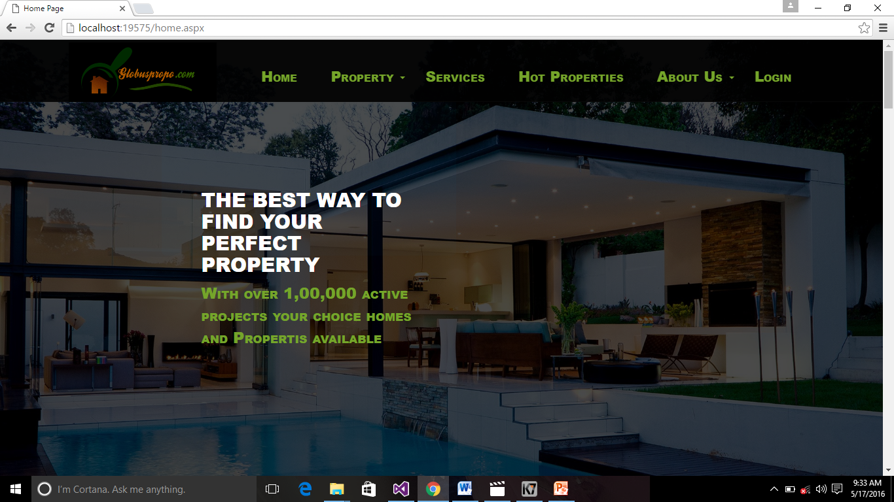

**3.7.1.1 Home Page**

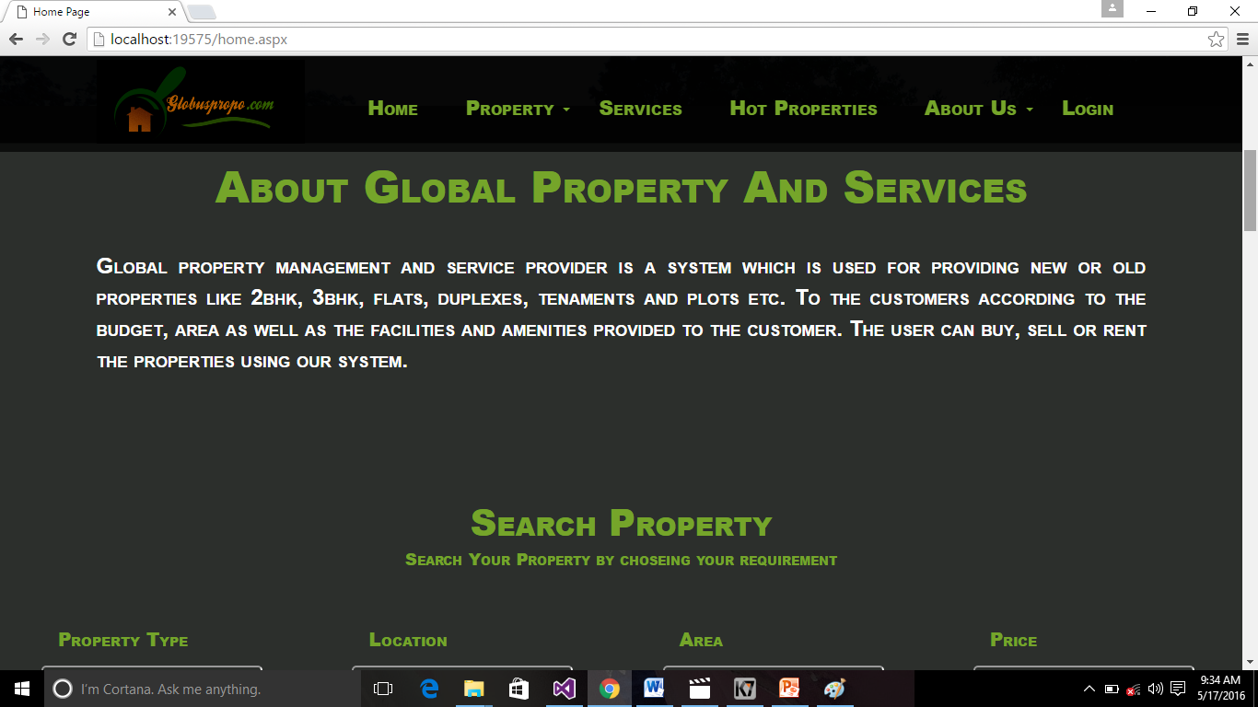

**3.7.1.2 Home Page**

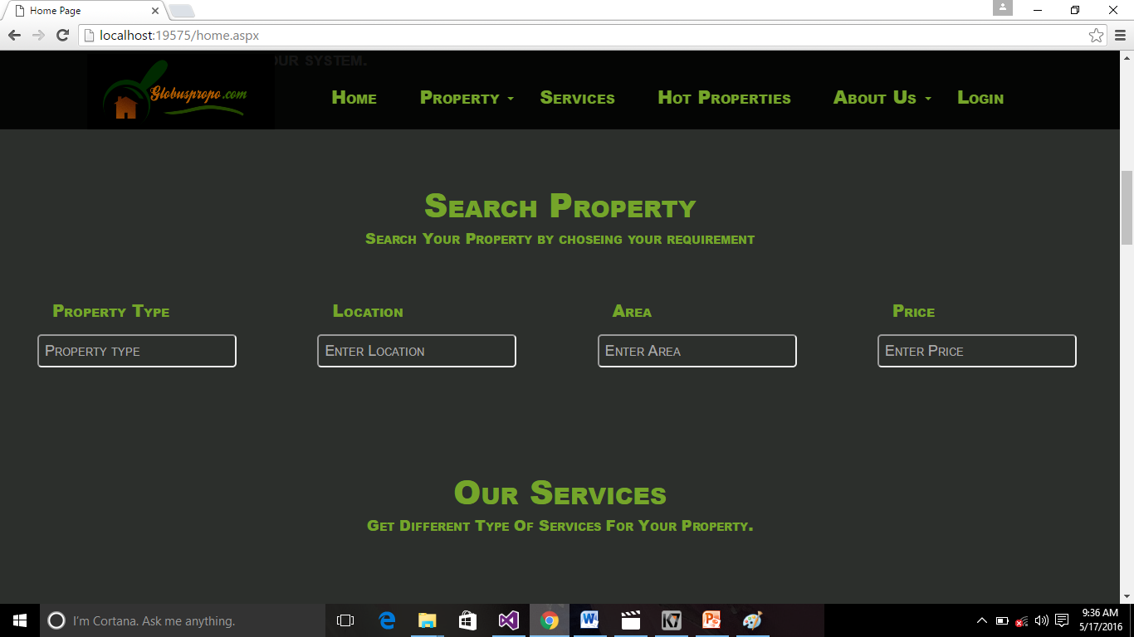

**3.7.1.3 Home Page**

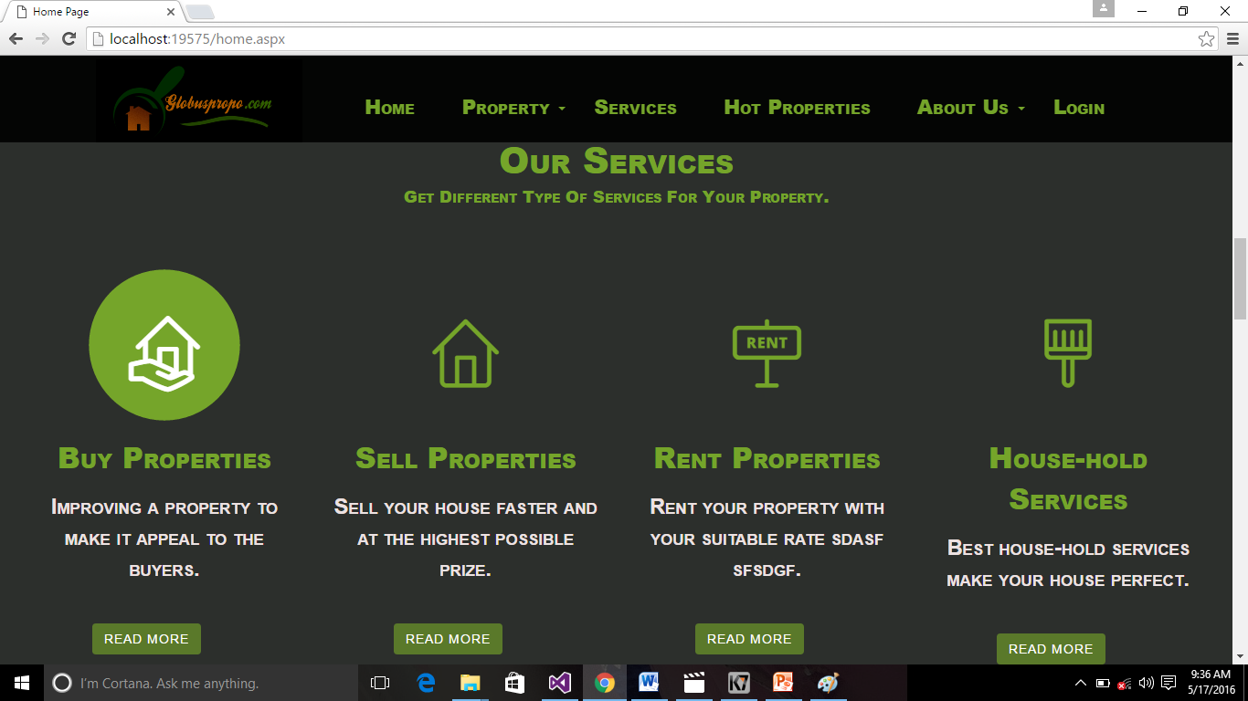

**3.7.1.4 Home Page**

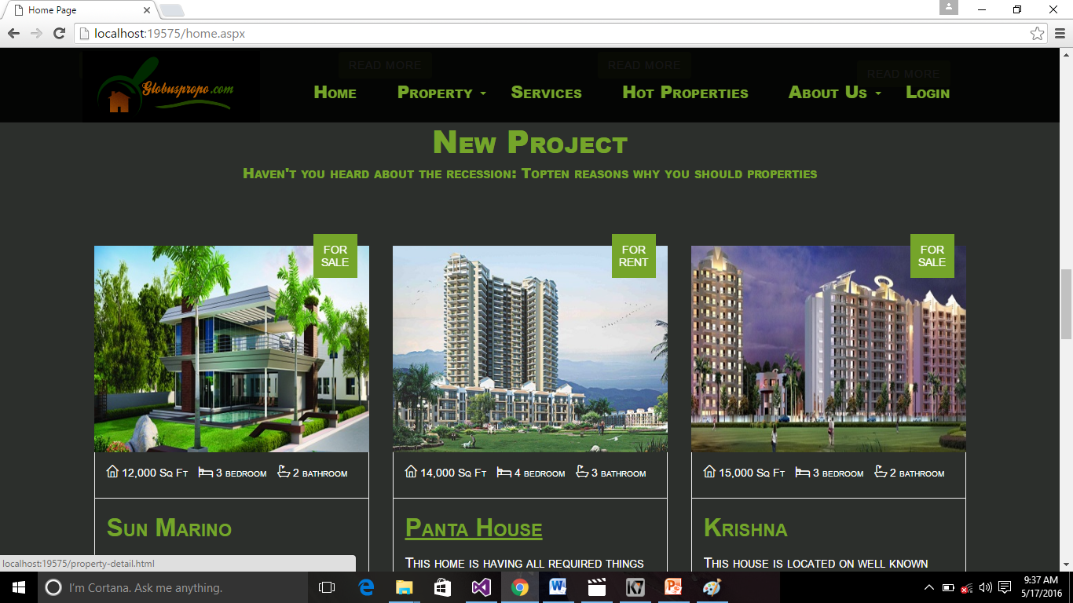

**3.7.1.5 Home Page**

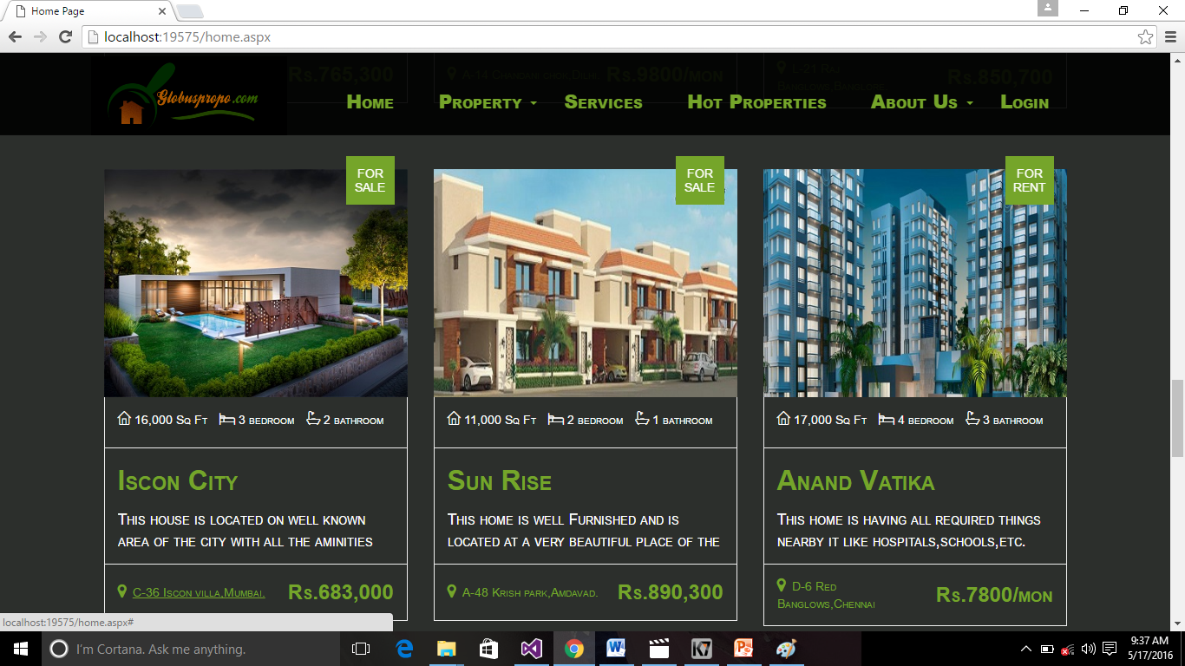

**3.7.1.6 Home Page**

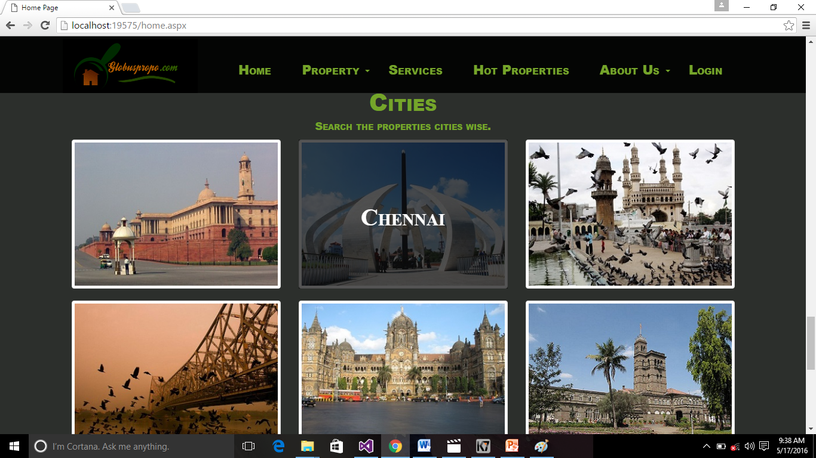

**3.7.1.7 Home Page**

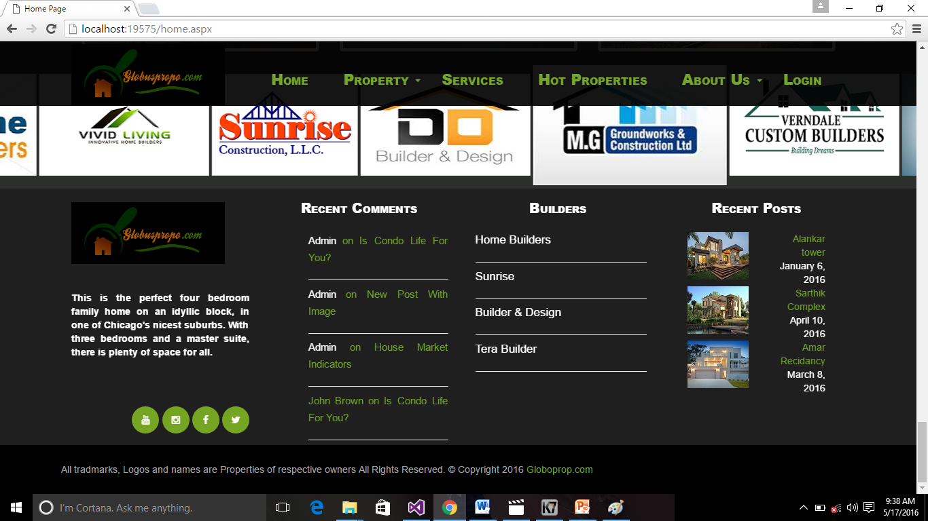

**3.7.1.8 Home Page**

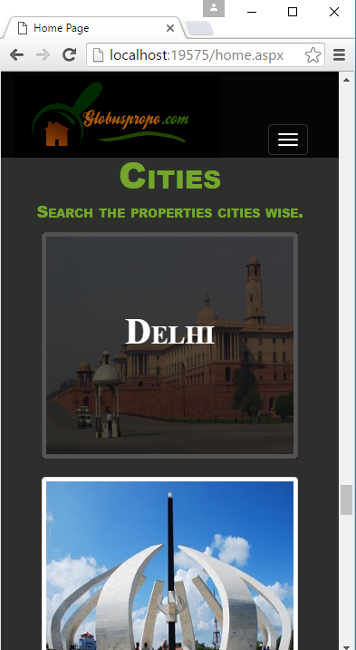

**3.7.1.9 Bootstrap view of Home Page**

**3.7.2 Login Page**

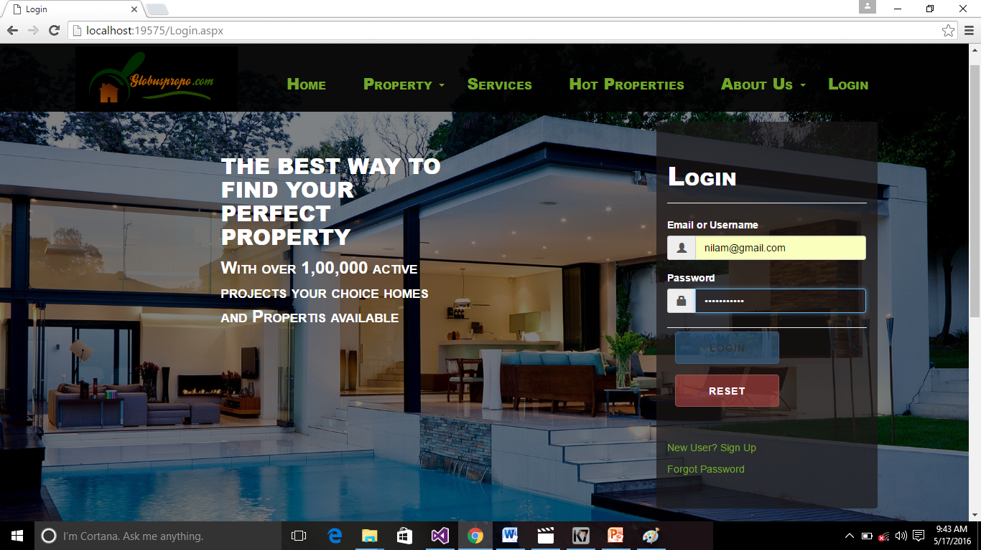

**3.7.2 Login Page**

**3.7.3 Registration Page**

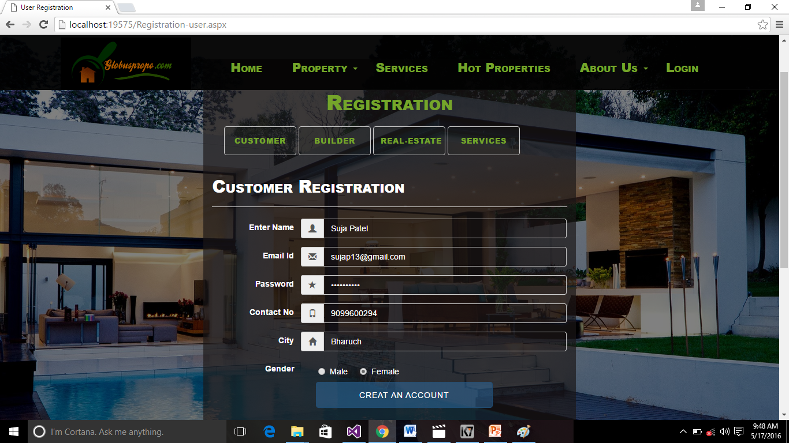

**3.7.3 Registration Page**

**3.7.4 Forgot Password**

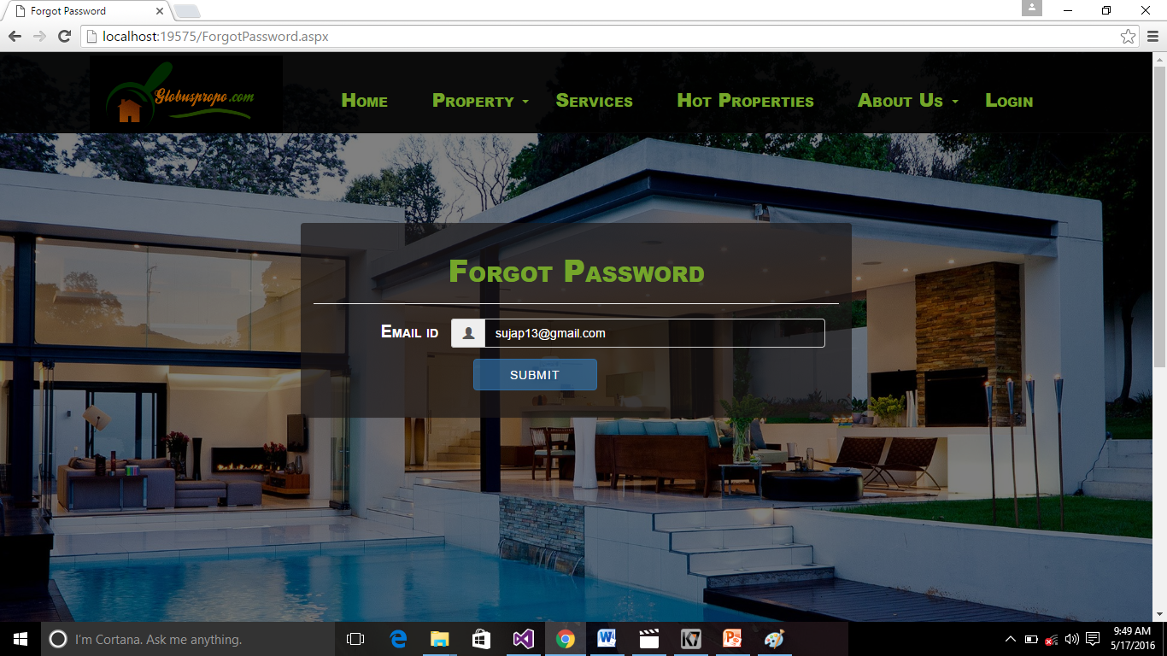

**3.7.4 Forgot Password**

**3.7.5 Customer-Homepage**

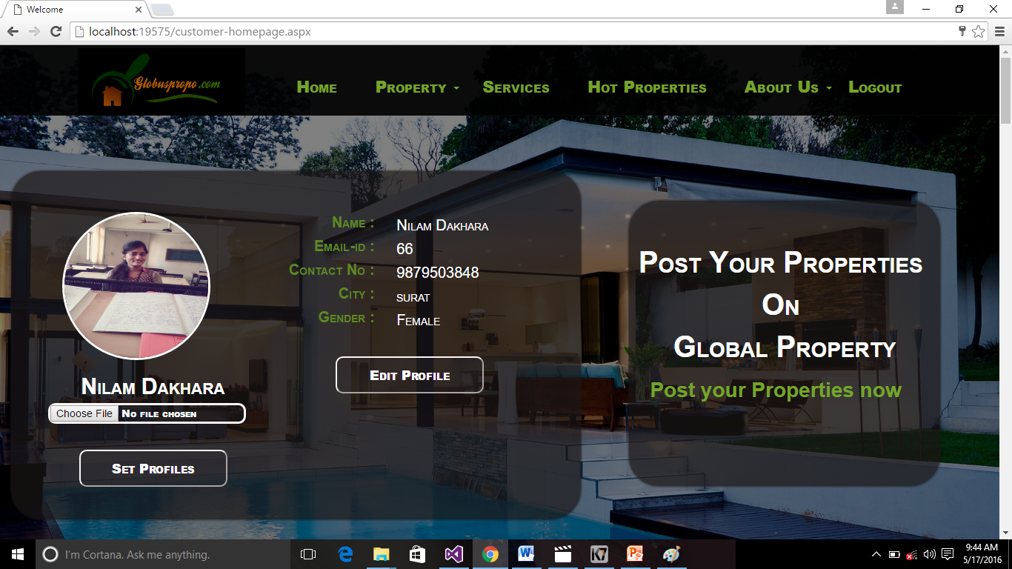

**3.7.5 Customer-Homepage**

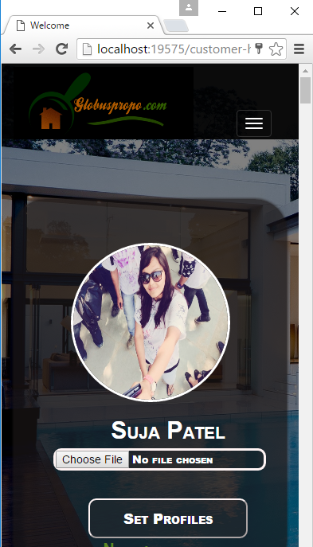

**3.7.5.1 Bootstrap view of Customer Homepage**

**3.7.6 Post Property**

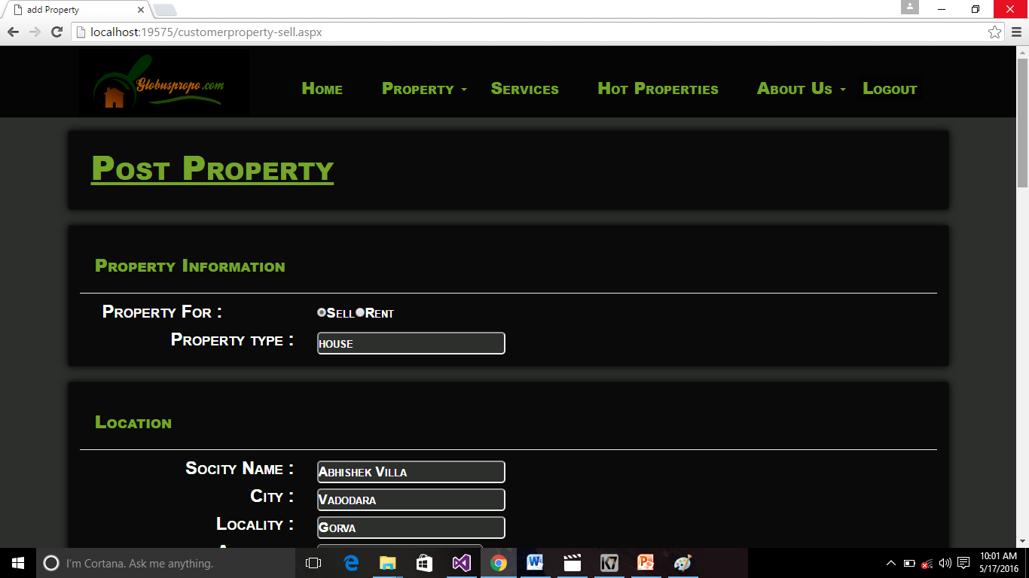

**3.7.6.1 Post Property**

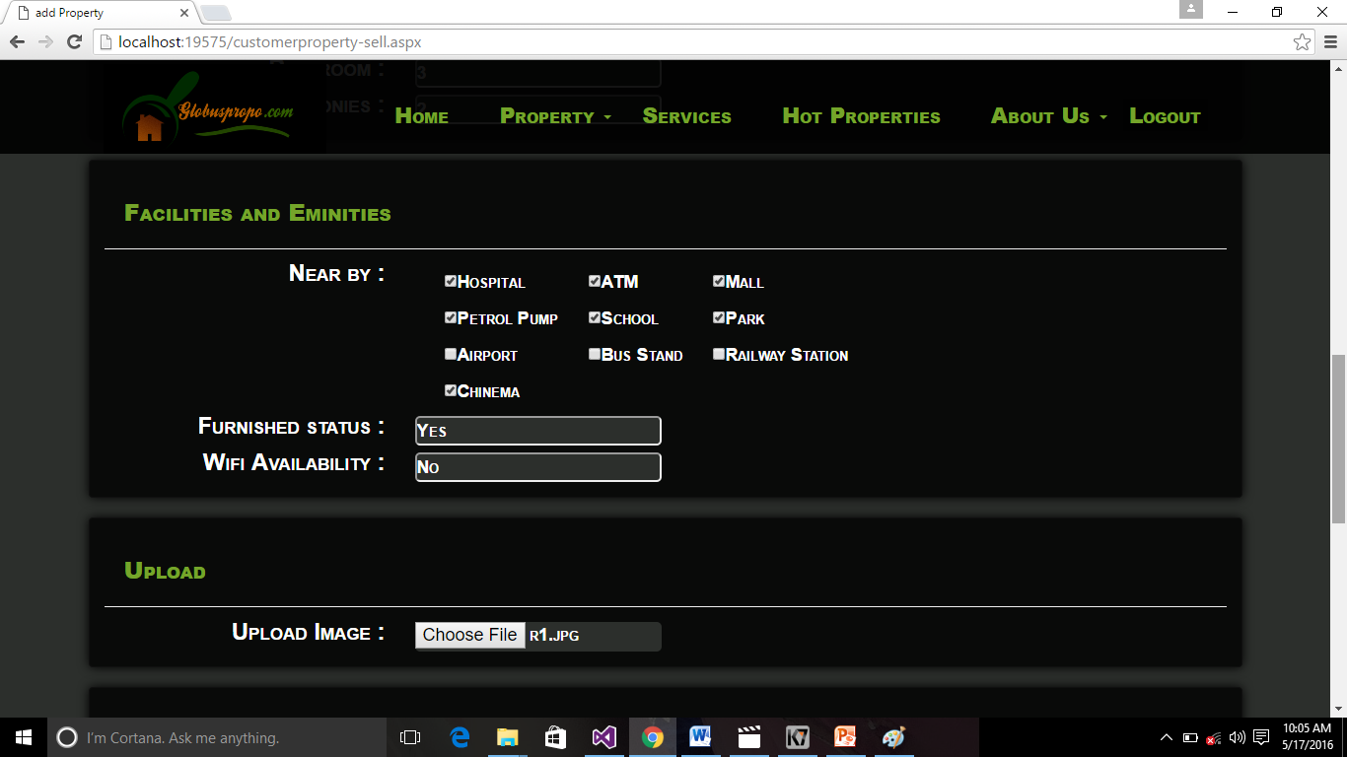

**3.7.6.2 Post Property**



**3.7.6.3 Post Property**

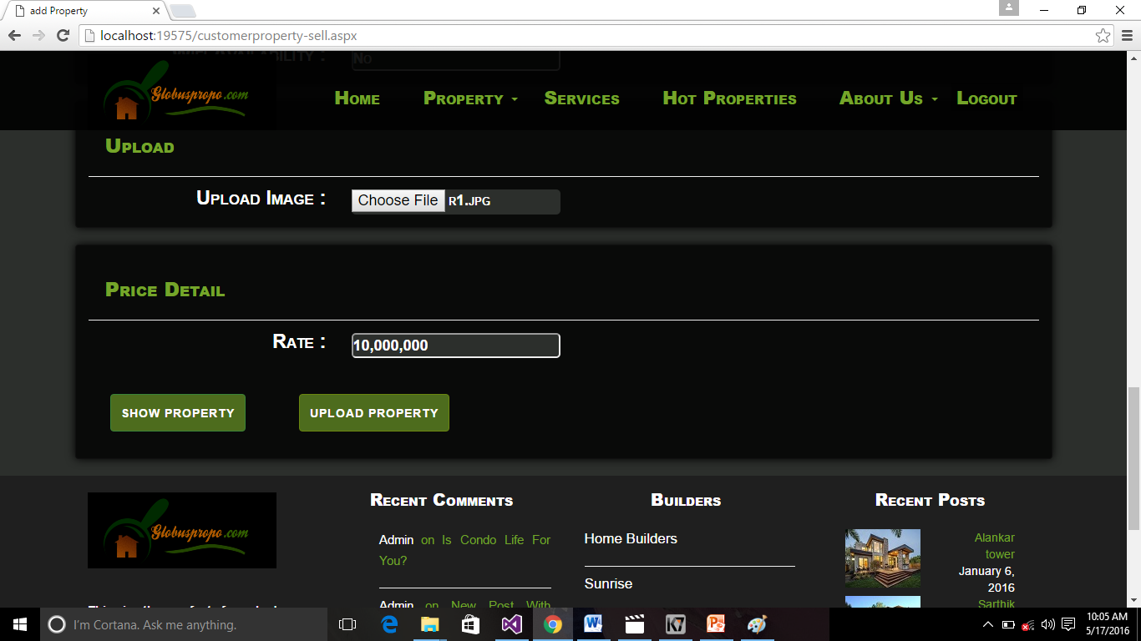

**3.7.6.4 Post Property**

**3.7.7 Show Property**

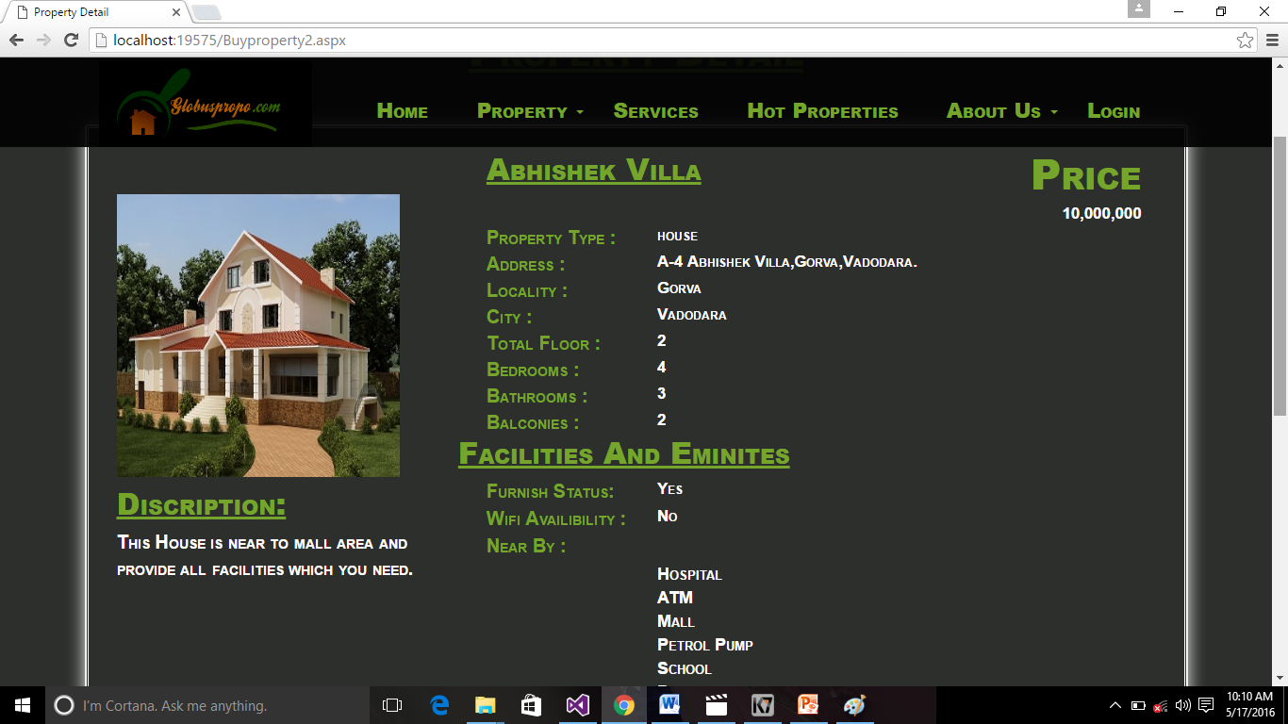

**3.7.7 Show Property**

**3.7.8 My Gallery**

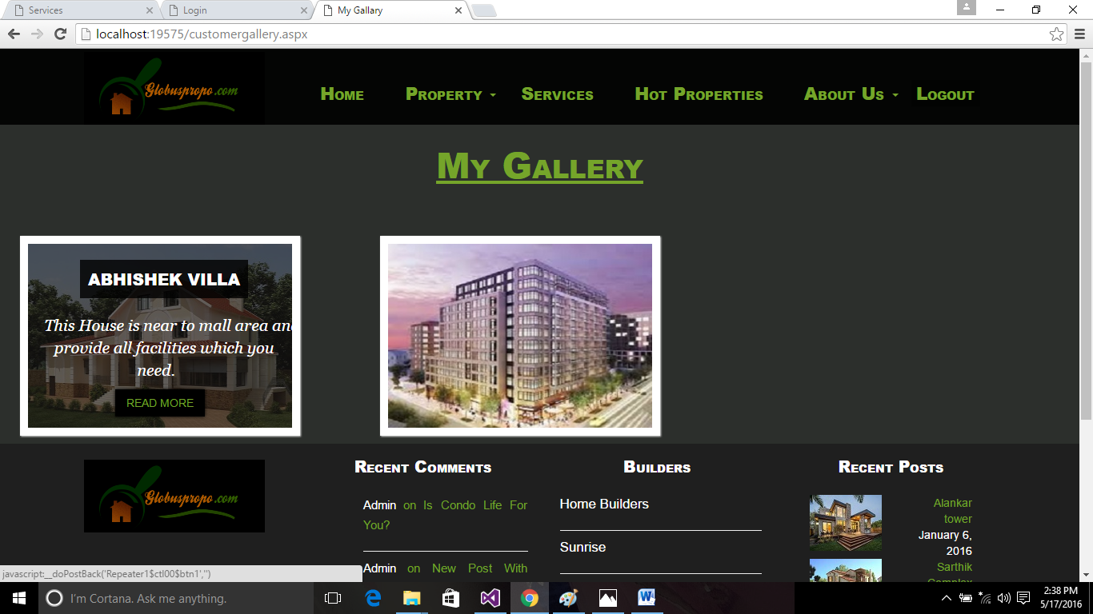

**3.7.8 My Gallery**

**3.7.9 Show Services**

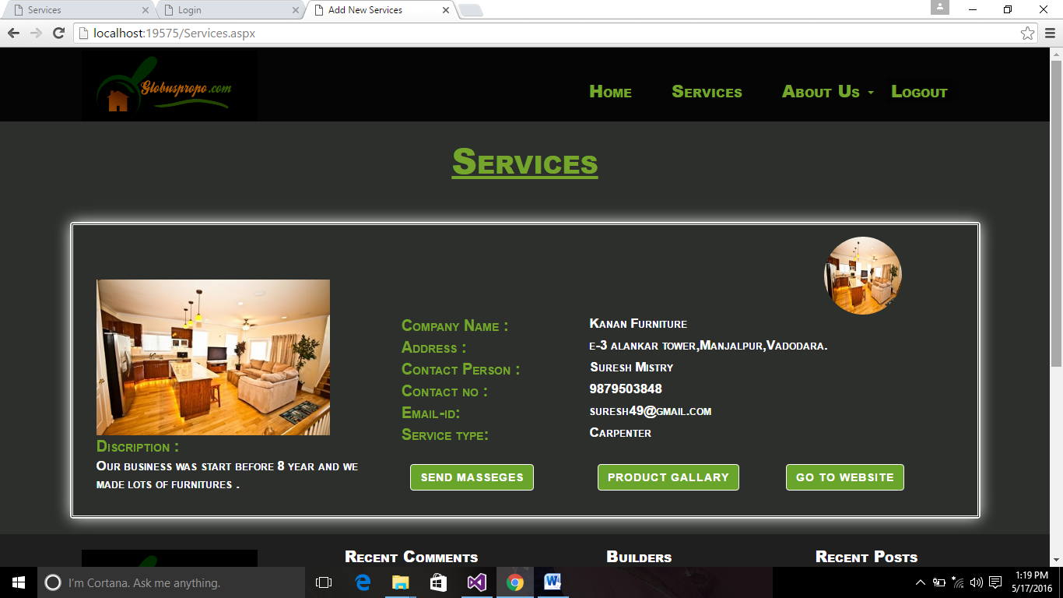

**3.7.9 Show Services**

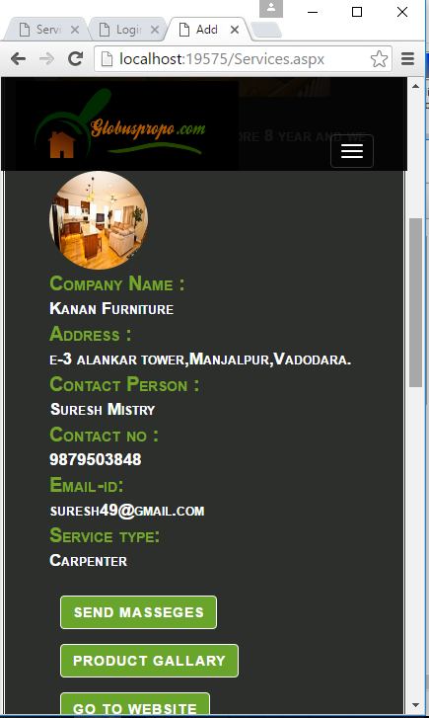

**3.7.9.1 Bootstrap view of Show Services**

**3.7.10 Contact Us**

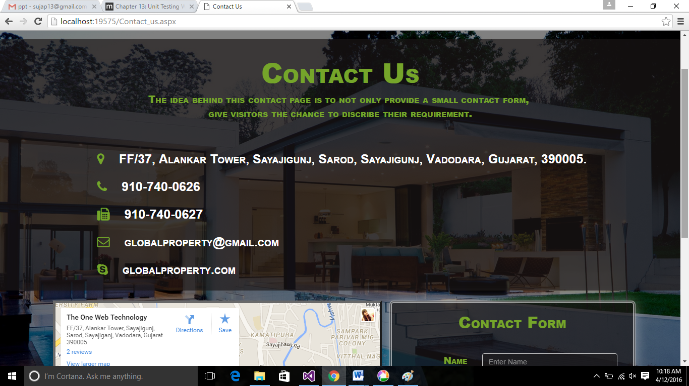

**3.7.10.1 Contact Us**

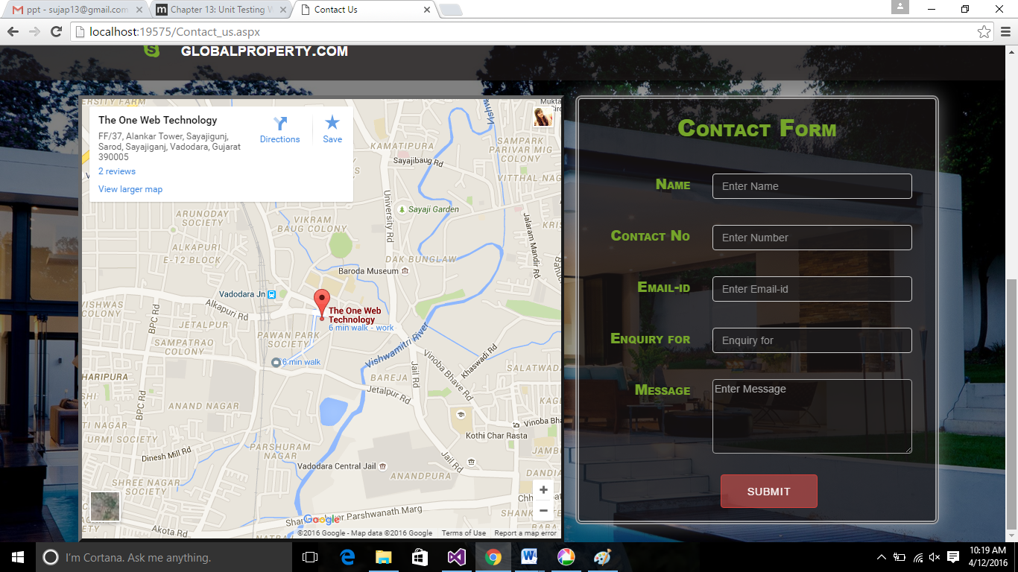

**3.7.10.2 Contact Us**

**3.7.11 Feed Back**

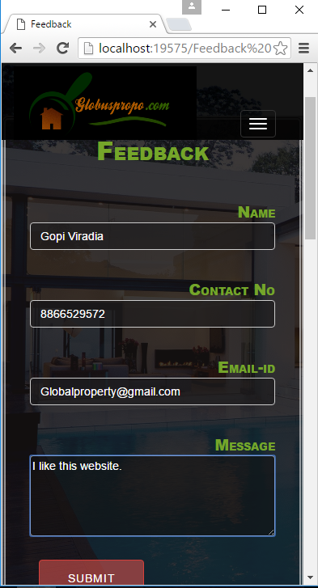

**3.7.11 Bootstrap view of Feedback Page**

**3.7.12 Admin Login page**

**3.7.13 Admin Page**

**Chapter 4:**

**Requirement Analysis**

The process of the system users needs to arrive at a definition of the problem domain and system requirements.

**Objectives**

To ensure survival and growth of management of different properties and different services provided to the customer. For use of this the advantage in future. The proposed model is easy to implement considering the available technology infrastructure. The models is simple, secure and scalable.

There are two kinds of requirements:

* Functional Requirements: which say what the system should do or how it should work
* Non-Functional Requirements: which say what constraints are there on the system and its development.

##### 4.1 User Characteristics:

##### The users of the system are members and the admin who maintain the system. The members are assumed to have basic knowledge of the internet surfing.

##### 4.2 Hardware Requirements:

This will be a Web application, and as such will be designed to interface with the hardware present on the phone and pc. Battery life is a product of the hardware and should be considered by the user when using our application, as this is dependent on the device being used. Sound will be supported, and should be turned on at times to experience the full functionality the product and should be considered by the user when using our system.

##### 4.3 Requirements for Development:

Internet connectivity should be enabled to provide feedback, registration and book property. The file storage system will be accessed to store user information and maintain persistent user data.

This product will be connecting remotely to a MySQL database that is already set up and is the same one that the edge website connects to. This allows for use in exercises by users of both computers and the phone. The software runs on any browser that will be utilized, including many prepackaged components to do things like create menus, look and feel, and other common functions expected of a website.

###### 4.3.1 Functional Requirements

* Application must run without failure.
* All data about the Customer must be properly stored in the database.
* Registered user must be able to access all the functionalities from one site.
* System must be able to generate the reports from the data obtained
* Builder’s authentication using user id and password.

**4.3.2 Non-Functional Requirements**

* Better component design to get better performance
* Flexible service based architecture will be highly desirable for future extension.
* Ease of Use-flexibility, performance
* Security- Privacy, Confidentiality, Integrity, Authentication.
* Comprehensiveness- Transferability, Divisibility, Standardization.
* Maintenance.

**Chapter 5**

**Coding, Testing and Implementation**

**5.1 Coding Standards**

1. Naming Conventions and Standards

|  |
| --- |
| Note :  The terms Pascal Casing and Camel Casing are used throughout this document.  **Pascal Casing** - First character of all words are Upper Case and other characters are lower case.  Example: BackColor  **Camel Casing -** First character of all words, except the first word are Upper Case and other characters are lower case.  Example: backColor |

1. Use Pascal casing for Class names

public class **HelloWorld**

{

...

}

1. Use Pascal casing for Method names

void**SayHello**(string name)

{ ...

}

1. Use Camel casing for variables and method parameters

int**totalCount** = 0;

voidSayHello(string name)

{

string**fullMessage** = "Hello " + name;

...

}

1. Use the prefix “I” with Camel Casing for interfaces ( Example: **IEntity** )
2. Do not use Hungarian notation to name variables.

In earlier days most of the programmers liked it - having the data type as a prefix for the variable name and using m_ as prefix for member variables For Example:

stringm_sName;

intnAge;

However, in .NET coding standards, this is not recommended. Usage of data type and m_ to represent member variables should not be used. All variables should use camel casing.

1. Use Meaningful, descriptive words to name variables. Do not use abbreviations.

Good:

string address

int salary

Not Good:

stringnam

stringaddr

intsal

1. Do not use single character variable names like i, n, s etc. Use names like index, temp

One exception in this case would be variables used for iterations in loops:

for ( int i = 0; i < count; i++ )

{

...

}

If the variable is used only as a counter for iteration and is not used anywhere else in the loop, many people still like to use a single char variable (i) instead of inventing a different suitable name.

1. Do not use underscores (_) for local variable names.
2. All member variables must be prefixed with underscore (_) so that they can be identified from other local variables.
3. Do not use variable names that resemble keywords.
4. Prefix boolean variables, properties and methods with “is” or similar prefixes.

Ex: private bool _isFinished

1. Namespace names should follow the standard pattern

<company name>.<product name>.<top level module>.<bottom level module>

1. Use appropriate prefix for the UI elements so that you can identify them from the rest of the variables.

There are 2 different approaches recommended here.

* 1. Use a common prefix ( ui_ ) for all UI elements. This will help you group all of the UI elements together and easy to access all of them from the intellisense.
  2. Use appropriate prefix for each of the ui element. A brief list is given below. Since .NET has given several controls, you may have to arrive at a complete list of standard prefixes for each of the controls (including third party controls) you are using.

|  |  |
| --- | --- |
| **Control** | **Prefix** |
| Label | lbl |
| TextBox | txt |
| DataGrid | dtg |
| Button | btn |
| ImageButton | imb |
| Hyperlink | hlk |
| DropDownList | ddl |
| ListBox | lst |
| DataList | dtl |
| Repeater | rep |
| Checkbox | chk |
| CheckBoxList | cbl |
| RadioButton | rdo |
| RadioButtonList | rbl |
| Image | img |
| Panel | pnl |
| PlaceHolder | phd |
| Table | tbl |
| Validators | val |

1. File name should match with class name.

For example, for the class HelloWorld, the file name should be helloworld.cs (or, helloworld.vb)

1. Use Pascal Case for file names.

### Write Short Methods: To the extent that it is feasible, methods should be kept small and focused. It is, however, recognized that long methods are sometimes appropriate, so no hard limit is placed on method length. If a method exceeds 40 lines or so, think about whether it can be broken up without harming the structure of the program.

**Define Fields in Standard Places:** Fields should be defined either at the top of the file, or immediately before the methods that use them.

**5.2 Software Testing**

**5.2.1 Overview of Test Method:**

You use ASP.NET unit tests to test methods that are part of ASP.NET projects. You can create an ASP.NET unit test in either of two ways:

* By generating the ASP.NET unit test from an ASP.NET project. This is the most common scenario.
* By configuring an existing unit test as an ASP.NET unit test.

You can also specify settings in a run configuration that correspond to the attributes used by ASP.NET unit tests. These procedures are described in the following sections.

|  |
| --- |
| When you run ASP.NET unit tests, do not use the [ClassCleanupAttribute](https://msdn.microsoft.com/en-us/library/microsoft.visualstudio.testtools.unittesting.classcleanupattribute(v=vs.80).aspx) or [ClassInitializeAttribute](https://msdn.microsoft.com/en-us/library/microsoft.visualstudio.testtools.unittesting.classinitializeattribute(v=vs.80).aspx) attributes on any method in a class that contains an ASP.NET unit test. Similarly, do not use the [AssemblyCleanupAttribute](https://msdn.microsoft.com/en-us/library/microsoft.visualstudio.testtools.unittesting.assemblycleanupattribute(v=vs.80).aspx) or [AssemblyInitializeAttribute](https://msdn.microsoft.com/en-us/library/microsoft.visualstudio.testtools.unittesting.assemblyinitializeattribute(v=vs.80).aspx) attributes in the same assembly as an ASP.NET unit test. The result of using these attributes in these situations is undefined. However, you can use the [TestInitializeAttribute](https://msdn.microsoft.com/en-us/library/microsoft.visualstudio.testtools.unittesting.testinitializeattribute(v=vs.80).aspx) and[TestCleanupAttribute](https://msdn.microsoft.com/en-us/library/microsoft.visualstudio.testtools.unittesting.testcleanupattribute(v=vs.80).aspx) attributes for any unit tests. |

Setup scripts and cleanup scripts run before and after test runs, regardless of the types of tests that are contained in those test runs. For more information about scripts that are run in conjunction with test runs, see [Test Deployment Overview](https://msdn.microsoft.com/en-us/library/ms182474(v=vs.80).aspx) and [How to: Specify a Test Run Configuration](https://msdn.microsoft.com/en-us/library/ms182480(v=vs.80).aspx).

# Generating an ASP.NET Unit Test

To generate an ASP.NET Unit Test, you first create an ASP.NET Web site within your Visual Studio solution. You then add a class to the Web site project, and finally, generate a unit test from that class.

### To generate an ASP.NET Unit Test

1. To generate an ASP.NET unit test, start by creating an ASP.NET Web site. To do this, right-click your solution, point to Add, and then click New Web Site.
2. On the Add New Web Site dialog box, click ASP.NET Web Site.
3. Under Location, click File System to indicate ASP.NET Development Server.
4. Click OK.

You now have a new Web site.

1. Add a class to this project. To do this, in Solution Explorer, right-click the Web site and then click Add New Item.
2. In the Add New Item dialog box, click Class, and then click Add.
3. A Microsoft Visual Studio dialog box is displayed to ask about placing the new class in the App Code folder. Click Yes.

|  |
| --- |
| You cannot generate tests from code in an .aspx file or in a folder other than the App Code folder. |

1. Generate an ASP.NET unit test. If the new class file is not already open, double-click it in Solution Explorer to open it.
2. Right-click the class in the class file, and then click Create Unit Tests.
3. The Create Unit Tests dialog box appears. For information about how to use this dialog box to generate unit tests, see [How to: Generate a Unit Test](https://msdn.microsoft.com/en-us/library/ms182524(v=vs.80).aspx).
4. Verify that the classes, methods, or namespaces for which you want to generate tests are selected.
5. (Optional) Accept the default Output project or select a new project.
6. When you are finished, click OK.

.

# Note   When you generate an ASP.NET unit test, these attributes are set automatically.

### To configure an ASP.NET unit test

1. Open the code file that contains the unit test.
2. Set the following attributes for the unit test:

[TestMethod]

Because all unit tests require the [TestMethod] attribute, this attribute will already be in place.

[UrlToTest()]

This is the URL that is tested when this unit test is run; for example, [UrlToTest(“<http://localhost/WebSites/Default.aspx>”)]

[HostType()]

Use [HostType(“ASP.NET”)]. Tests are typically run under the VSTest host process, but ASP.NET unit tests must run under the ASP.NET host process.

Examples

Example 1. If you are running your Web site with the ASP.NET Development Server, the attributes and values you set for an ASP.NET unit test might resemble the following:

[TestMethod()]

[HostType("ASP.NET")]

[UrlToTest("http://localhost:25153/WebSite1")]

[AspNetDevelopmentServerHost("D:\\Documents and Settings\\user name\\My Documents\\Visual Studio 2005\\WebSites\\WebSite1", "/WebSite1")]

Example 2. To test a Web site running under IIS, use only the attributes TestMethod, HostType, and UrlToTest:

[TestMethod()]

[HostType("ASP.NET")]

[UrlToTest("http://localhost:25153/WebSite1")]

# Configuring ASP.NET Unit Tests Using Run Configuration

You can specify settings in a run configuration that correspond to the attributes used by ASP.NET unit tests. After you have specified these attributes in a run configuration, the settings will apply when you run any ASP.NET unit test, whenever that run configuration is active.

|  |
| --- |
| Only one set of settings for ASP.NET unit tests can be in effect: run configuration settings or attribute settings, but never a mixture of the two. Run configuration settings take precedence over attributes, if present. This means that even if you specify only one ASP.NET setting in run configuration, any ASP.NET settings specified as attributes are ignored. |

### To configure ASP.NET unit tests using run configuration

1. Open a run configuration file. For more information, see [How to: Specify a Test Run Configuration](https://msdn.microsoft.com/en-us/library/ms182480(v=vs.80).aspx).
2. On the Hosts page, set the Host Type to ASP.NET.

This displays additional choices, some of which correspond to attributes you can specify in code, such as Url to Test. These attributes are described in the previous procedure, "Configuring an ASP.NET Unit Test."

When you have finished setting the values on the Hosts page, click Save and then click OK.

**5.2.2 Modules of Testing:**

The Android testing framework, an integral part of the development environment, provides an architecture and powerful tools that help you test every aspect of your application at every level from unit to framework.

The testing framework has these key features:

* Android test suites are based on JUnit. You can use plain JUnit to test a class that doesn't call the Android API, or Android's JUnit extensions to test Android components. If you're new to Android testing, you can start with general-purpose test case classes such as AndroidTestCase and then go on to use more sophisticated classes.
* The Android JUnit extensions provide component-specific test case classes. These classes provide helper methods for creating mock objects and methods that help you control the lifecycle of a component.
* Test suites are contained in test packages that are similar to main application packages, so you don't need to learn a new set of tools or techniques for designing and building tests.

The SDK tools for building and tests are available in Eclipse with ADT, and also in 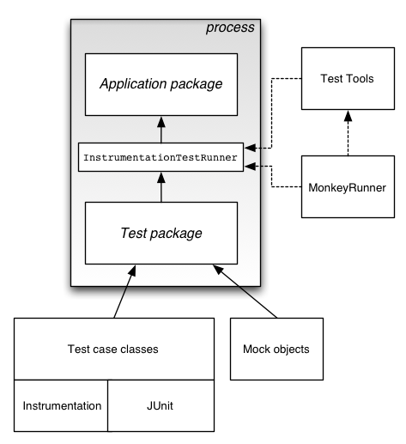of the application under test and use this information to automatically create the build files, manifest file, and directory structure for the test package.

* The SDK also provides monkey runner, an API for testing devices with Python programs, and UI/Application Exerciser Monkey, a command-line tool for stress-testing UIs by sending pseudo-random events to a device.

# Testing from Eclipse with ADT

This topic explains how create and run tests of Android applications in Eclipse with ADT. Before you read this topic, you should read about how to create an Android application with the basic processes for creating and running applications with ADT, as described in Managing Projects from Eclipse and Building and Running from Eclipse. You may also want to read Testing Fundamentals, which provides an overview of the Android testing framework.

ADT provides several features that help you set up and manage your testing environment effectively:

* It lets you quickly create a test project and link it to the application under test. When it creates the test project, it automatically inserts the necessary <instrumentation> element in the test package's manifest file.
* It lets you quickly import the classes of the application under test, so that your tests can inspect them.
* It lets you create run configurations for your test package and include in them flags that are passed to the Android testing framework.
* It lets you run your test package without leaving Eclipse. ADT builds both the application under test and the test package automatically, installs them if necessary to your device or emulator, runs the test package, and displays the results in a separate window in Eclipse.

# Testing from Other IDEs

This document describes how to create and run tests directly from the command line. You can use the techniques described here if you are developing in an IDE other than Eclipse or if you prefer to work from the command line. This document assumes that you already know how to create a Android application in your programming environment. Before you start this document, you should read the topic Testing Fundamentals, which provides an overview of Android testing.

If you are developing in Eclipse with ADT, you can set up and run your tests directly in Eclipse. For more information, please read Testing from Eclipse with ADT.

1. **Activity Testing**

Activity testing is particularly dependent on the Android instrumentation framework. Unlike other components, activities have a complex lifecycle based on callback methods; these can't be invoked directly except by instrumentation. Also, the only way to send events to the user interface from a program is through instrumentation.

1. **Service Testing**

Android provides a testing framework for Service objects that can run them in isolation and provides mock objects. The test case class for Service objects is ServiceTestCase. Since the Service class assumes that it is separate from its clients, you can test a Service object without using instrumentation.

1. **Content Provider Testing**

Content providers, which store and retrieve data and make it accessible across applications, are a key part of the Android API. As an application developer you're allowed to provide your own public providers for use by other applications. If you do, then you should test them using the API you publish

1. **Accessibility Testing**

Testing is an important part of making your application accessible to users with varying abilities. Following design and development guidelines for accessibility are important steps toward that goal, but testing for accessibility can uncover problems with user interaction that are not obvious during design and development.

1. **UI Testing**

In addition to unit testing the individual components that make up your Android application (such as activities, services, and content providers), it is also important that you test the behavior of your application’s user interface (UI) when it is running on a device. UI testing ensures that your application returns the correct UI output in response to a sequence of user actions on a device, such as entering keyboard input or pressing toolbars, menus, dialogs, images, and other UI controls.

Functional or black-box UI testing does not require testers to know the internal implementation details of the app, only its expected output when a user performs a specific action or enters a specific input. This approach allows for better separation of development and testing roles in your organization.

One common approach to UI testing is to run tests manually and verify that the app is behaving as expected. However, this approach can be time-consuming, tedious, and error-prone. A more efficient and reliable approach is to automate the UI testing with a software testing framework. Automated testing involves creating programs to perform testing tasks (test cases) to cover specific usage scenarios, and then using the testing framework to run the test cases automatically and in a repeatable manner.

**5.2.3 Testing Strategy:**

Various elements of an effective mobile application testing strategy are considered in this section. Recommendations in this section are based onTCS’extensive experience in developing and testing scores of mobile applications.

**SelectingTarget Devices**

Target devices for testing a mobile application should balance the need to use a representative sample of the expected device population with the need to optimize duration and cost of testing.

**Simulators vs. Physical Devices**

Use of device simulators can be highly effective in the early stages of product development when features are under development. Simulators are useful to familiarize the test team with various application features.

Figure illustrates various conditions under which testing with simulators and real devices can be effective. Simulators can be effectively used for testing basic application functionality. Testing on physical devices is essential to understanding application behavior such as touch response and user experience. Stable, defect-free (based on simulator testing) features can then be tested on physical devices. Device usage can be optimized by distributing test cases across various types of devices.

Note that this strategy requires that the test tools being used support testing with simulators as well as devices.

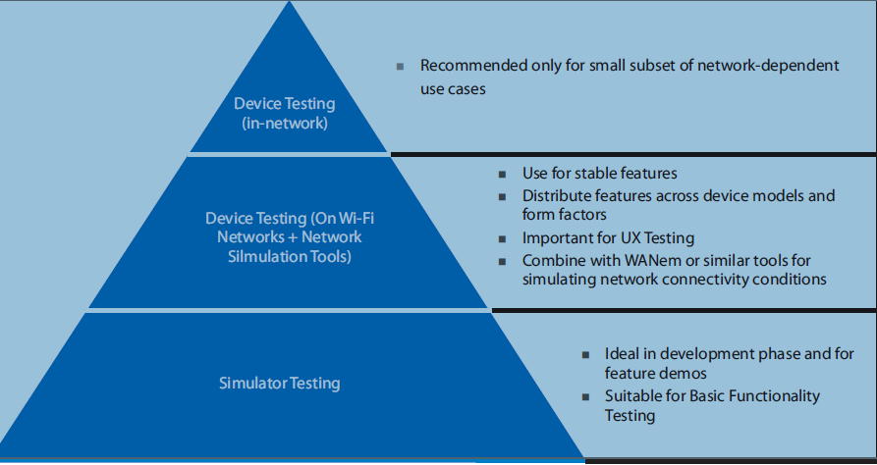

**Conditions for Testing with Devices / Simulators and Different Connectivity Options**

**Device Model Selection**

Key factors in deciding specific device models for testing are –

In OS Version – Applications should be tested on all major OS versions in the current installed base. For Android devices, OS distribution of various Android versions provided by Google at [http://developer.android.com/about/dashboar](http://developer.android.com/about/dashboards/index.html)ds/index.html can be used to determine the mix of Android versions to be targeted

**Form Factor** – Applications may behave differently (especially in terms of user experience) on smart phones and tablets. If the test application supports both smartphones and tablets, it should be tested on both form factors

**Display Density** –The screen size and screen resolution of a device (aka display density) can also affect application user experience (e.g. look and feel of UI, rendering of web pages). Device models selected for testing should include a mix of different display densities.

A variety of other factors (keyboard, CPU type, memory) can affect specialized applications that rely on specific device features and should be taken into account when necessary.

When testing enterprise applications, a user survey or device model data from internal systems can be a good source of information to determine the mix of target devices for testing

**Connectivity Options**

Almost all applications rely on network connectivity to provide useful functionality. In test environments, Wi-Fi networks can be easy to set up and can be cost effective, unlike cellular connectivity that can be both unreliable and expensive.

**5.2.4 Test Cases:**

 ASP.NET MVC fully supports Test Driven Development approach where you can write your test cases first and on the basis of output or result you can write your actual code for development. Any Software which has their Data Access Layer or Business Layer, they should be tested before going to production. If these layers are tested it means you are going in right direction.  
  
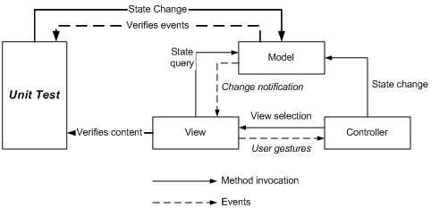

You can write test cases for all Public Methods, which needs to be tested.  
First you just need to create an ASP.NET MVC application. To create a new ASP.NET MVC application with Test Project, Open **Visual Studio** choose **File, New,**then **Project**.  
It will open a **New Project**window, from where you need to choose node as **Visual C# and then Web**and from the right pane you need to choose **ASP.NET Web Application.** Name the application.

**Conclusion**

At last we would like to conclude that our system is very useful for new generation mostly, who don't have much time to find new properties. Because this helps in saving time and money as well. The global property management and service provider system will also help by providing different services.

**References**

[1.] ASP .NET. .,Website:http://www.asp.net/

[2.] ASP .NET Architecture. http://www.dotnet-tricks.com/Tutorial/aspnet/SaJc221013-Understanding-Detailed-Architecture-of-ASP.NET-4.5.html

[3.] ASP .NET Library:Available from:

<https://msdn.microsoft.com/en-us/library/ms644559(v=vs.85).aspx>

[4.] ASP .NET Security:Available from:

http://www.tutorialspoint.com/asp.net/asp.net_security.htm

[5.]ASP .NET Tutorials:http://www.w3schools.com/aspnet/

[6.] https://www.youtube.com/?gl=IN

[7.] http://www.tutorialspoint.com/uml/

**[8.] http://www.ebizel.com/education/**